Schoenfeld B. J. - NSCA’s Essentials of Personal Training

Chapter 1 - Structure and Function of the Muscular, Nervous, and Skeletal Systems
Note: I'll skip all the complicated anatomic names, and write only important concepts.
- Muscles generate force when they are activated. This is referred to as a muscle contraction or muscle action. Of the three types of muscle - smooth, cardiac, and skeletal - it is the third type that attaches to bones, causing them to rotate around joints.
- Most relevant muscles:
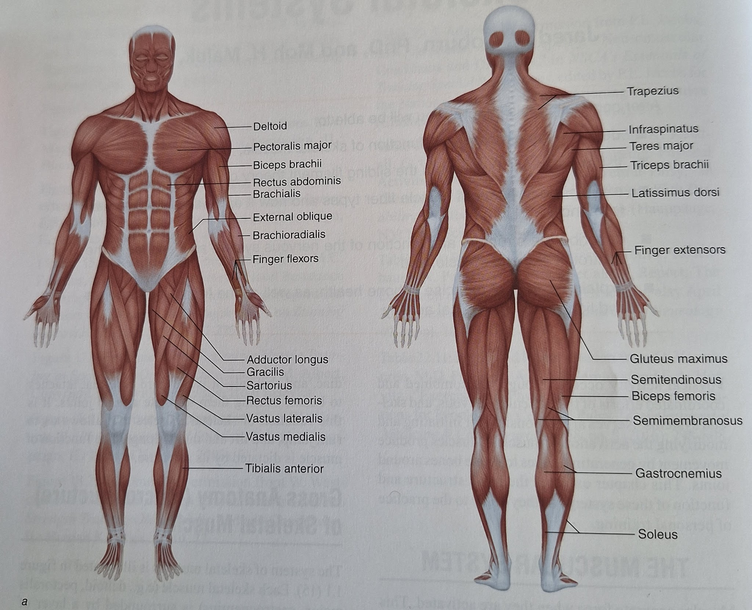
- The sliding filament theory states that a muscle shortens or lengthens when the filaments (actin and myosin) slide past each other, without the filaments themselves changing in length.
- It is important to recognize that when stimulated muscle fibers always attempt to shorten.
- If the amount of force produced by a muscle is greater than the external resistance acting in the opposite direction, a concentric muscle action will result. During a concentric muscle action, the resistance is overcome and the muscle shortens. If the amount of force produced by a muscle is less than an opposing external resistance, the muscle will lengthen even as it attempts to shorten. This lengthening muscle action is known as an eccentric muscle action. Lastly, if the muscle force is equal and opposite to that of an external resistance. an isometric (static) muscle action results. In this case the muscle neither shortens nor lengthens but remains the same length.
- It is not uncommon to experience muscular pain and discomfort 24 to 48 hours after beginning an exercise program or performing novel exercises. This delayed- onset muscle soreness (DOMS) likely results from some combination of connective and muscle tissue damage followed by an inflammatory reaction that activates pain receptors.
Strategies to combat the pain and performance decrements result- ing from DOMS have included nutritional supplements, massage, ice, and ultrasound (1, 2). It appears, however, that exercise itself may be the best means of decreasing pain associated with DOMS.
- Slow fibers have alternatively been referred to as type I, slow oxidative (SO), or slow-twitch fibers. As can be inferred from the name, these fibers have high oxidative capacity and are fatigue resistant, but they contract and relax slowly. The two types of fast fibers are known as type IIa, fast oxidative glycolytic (FOG), and type IIx, fast glycolytic (FG) fibers. Both fast fiber types are large and powerful, with moderate to high anaerobic metabolic capability. The primary distinction between the two is that FOG fibers have moderate oxidative and anaerobic capacity, providing them with some fatigue resistance in comparison with the purely anaerobic and highly fatigable FG fibers. It should be acknowledged, however, that the characteristics by which fibers are categorized into types lie on a continuum rather than being discrete categories.
- Both type I and type II fibers will increase in size in response to regular resistance training.
- Anatomically, the entire nervous system can be divided into the central nervous system and peripheral nervous system. The central nervous system consists of the brain and spinal cord. As its name implies, the peripheral nervous system lies outside the central system and may be further divided into nervous motor (efferent) and sensory (afferent) divisions. The motor branch of the peripheral nervous system relays nerve impulses from the central nervous system to the periphery, while the sensory branch relays nerve impulses from the periphery back to the central nervous system.
- The nervous system has somatic (voluntary) and autonomic (involuntary) functions.
- If the force of the muscle action is great enough, it will cause the Golgi tendon organ to convey sensory information to the spinal cord, which will lead to relaxation of the acting muscle and stimulation of the antagonist muscle. This protective reflex presumably prevents injury to the muscle and joint due to a potentially excessive force of muscle action.
- There are two mechanisms the nervous system may use to vary, or grade, force production to accomplish these tasks. One method is to vary the number of motor units and thus muscle fibers that are activated. This is known as motor unit recruitment. The second method is to increase the firing rate of motor units already activated, a process known as rate coding.
- Motor units are recruited in a specific order, known as the size principle of motor unit recruitment. The first motor units recruited are the smaller type I motor units. which have a lower threshold for being activated and thus are recruited even during low-force muscle actions. The next motor units recruited are the type IIa motor units followed by the type IIx motor units.
- The typical person has 206 bones that make up the skeletal system. The bones can be divided into two anatomical divisions: the axial skeleton and the appendicular skeleton. The axial skeleton consists primarily of the skull, vertebral column. sternum, and ribs. The appendicular skeleton includes the bones of the upper and lower limbs.
- Most relevant bones:
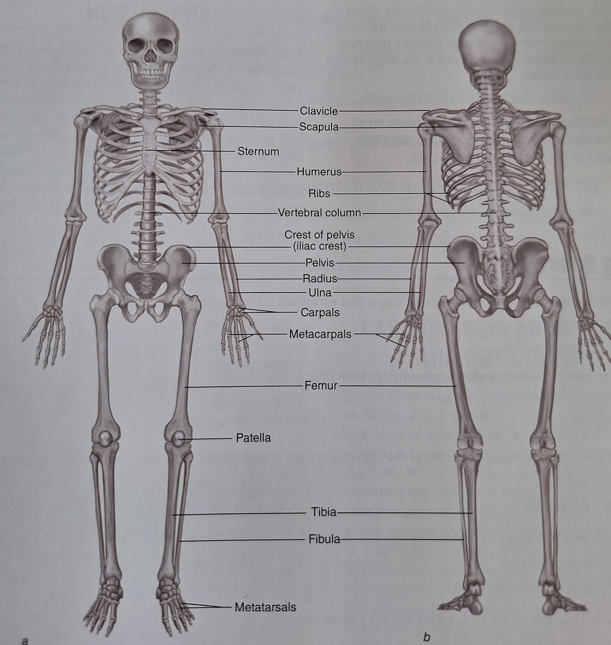
- Osteoporosis, literally meaning "porous bones," is a condition in which the bones become weak and brittle. In this weakened condition, they are more susceptible to breaking, particularly in the spine and hip. Along with proper nutrition, including adequate calcium intake, exercise is an important component of bone health. According to Wolff's law, bone will adapt in response to stresses placed on it.
- Resistance training increases bone mass and strength and may decrease the likelihood of developing osteoporosis.
- Tendons attach muscle to bone.
- Ligaments connect bones to other bones.

Chapter 2 - Structure and Function of the Cardiorespiratory System
Note: I'll skip all the complicated anatomic names, and write only important concepts.
- The cardiovascular and pulmonary systems work together to deliver important nutrients to the functioning tissues of the body and remove the by-products of metabolism. The two systems are described collectively as the cardiorespiratory system, comprising the heart, blood, blood vessels, and lungs. The system is well integrated with the body and responds accordingly to a change in metabolic demand.
- Oxygen is primarily carried by hemoglobin but is also dissolved within the blood. Oxygen dissolved in the blood accounts for a very small percentage.
- The average healthy adult who is not anemic has around 5.0 L of blood volume. which accounts for close to 7% of body weight.
- A common misconception is that deoxygenated blood has no oxygen whereas in fact, at rest it is approximately 70% saturated.
- The circulation of the heart and lungs central circulation) and that of the rest of the body (peripheral circulation) form a single closed-circuit system with two components: an arterial system, which carries blood away from the heart, and a venous system, which returns blood toward the heart.
- Arteries are typically a high-pressure system. The veins are characterized by very low pressure relative to the arteries.
- The autonomic nervous svstem controls the activitv of internal oraans. such as the heart and blood vessels. For example, the two branches of the autonomic nervous system, parasympathetic and sympathetic act together to regulate heart rate. The parasympathetic system is active during rest by keeping heart rate low. However, the sympathetic system becomes more active during exercise by increasing heart rate. The autonomic nervous system also helps control how much blood is redistributed to active muscle during exercise.
- The primary function of the respiratory system is the basic exchange of oxygen and carbon dioxide.
- As air passes through the nose, the nasal cavities perform three distinct functions. which include warming, humidifying, and purifying the air.
- During exercise, the internal intercostal and abdominal muscles facilitate movement of air in and out of the lungs.
- Spirometry is a method used in either clinical or research settings to examine static lung volumes. The test measures lung function as the individual breathes into a special tube connected to a spirometer device, measuring the amount and speed of air that is inhaled and exhaled.
- Oxygen uptake (V02) is the amount of oxygen used by the tissues of the body.
- Maximal oxygen uptake (VO,max) is the highest amount of oxygen that can be taken up, transported and used by the body. This entire process is related to the heart's maximal ability to eject blood, the maximal ability of skeletal muscle to extract oxygen, and the ability to use it to aerobically produce energy. The process by which VOmax is accurately obtained is a graded exercise test (GXT) on an aerobic exercise machine like a treadmill.
- VO2max, or VO2peak, is the most accepted measure of aerobic fitness, also known as cardiovascular fitness. It correlates well with the degree of physical conditioning and is related to cardiovascular health.
- Aerobic endurance training leads to increased maximal oxygen uptake. The changes are related, in part, to an increase in stroke volume and peripheral adapta- tions (i.e.. increased capillary and mitochondrial density).

Chapter 3 - Bioenergetics
- Bioenergetics, or the flow of energy in a biological system, primarily concerns the conversion of food - or large carbohydrate, protein, and fat molecules that contain chemical energy - into biologically usable forms of energy.
- The process of breaking down large molecules into smaller molecules is generally accompanied by the release of energy and is termed catabolic.
- The synthesis of larger molecules from smaller molecules can be accomplished using the energy released from catabolic reactions. This building-up process is termed anabolic.
- The human body is in a constant state of anabolism and catabolism which is defined as metabolism, or the total of all the catabolic and anabolic reactions in the body.
- Energy obtained from catabolic reactions is used to drive anabolic reactions through an intermediate molecule, adenosine triphosphate (ATP).
- Energy stored in the chemical bonds of ATF is used to power muscular activitv. The replenishment of ATP in human skeletal muscle is accomplished by three basic energy systems: phosphagen, glycolytic and oxidative.
- The phosphagen system is the primary source of ATP for short-term. high-intensity activities (e.g. jumping and sprinting) but is active at the start of all types of exercise regardless of intensity.
- The ATP provided by glycolysis supplements the phosphagen system initially and then becomes the primary source of ATP for high-intensity muscular activity that lasts up to about 2 minutes, such as keeping a good volley going in a rigorous game of racquetball or running 600 to 800 yards (or meters).
- The oxidative system, the primary source of ATP at rest and during aerobic activities, uses primarily carbohydrates and fats as substrates. Clients who are walking on a treadmill, doing water aerobics, or participating in a yoga class are relying primarily on the oxidative system. Protein is normally not metabolized significantly except during long-term starvation and long steady-state bouts (90 minutes) of exercise. At rest, approximately 70% of the ATP produced is derived from fats and 30% from carbohydrates.
After the onset of activity, as the intensity of the exercise increases, there is a shift in substrate preference fron fats to carbohydrates. During high-intensity aerobic exercise, almost 100% of the energy is derived fron carbohydrates if an adequate supply is available However, during prolonged, submaximal, steady-state work there is a gradual shift from carbohydrates back to fats and protein as energy substrates.
  - Glucose and Glycogen Oxidation
  - Fat Oxidation
  - Protein Oxidation
- All three energy systems are active at a given time; however, the extent to which each is used depends primarily on the intensity of the activity and secondarily on its duration.
- Exercise intensity is defined as a level of muscular activity that can be quantified in terms of power output, with power defined as the amount of physical work performed for a particular duration of time.
- Short, high-intensity activities (e.g., jumping or kicking and punching moves in cardio kickboxing) rely on the phosphagen energy system and fast glycolysis. As the intensity decreases and the duration increases, the emphasis gradually shifts to slow glycolysis and the oxidative energy system.
- There is an inverse relationship between the relative rate and total amount of ATP that a given energy system can produce.
- The phosphagen energy system primarily supplies ATP for high-intensity activities of short duration, the glycolytic system for moderate- to high-intensity activities of short to medium duration, and the oxida- tive system for low-intensity activities of long duration.
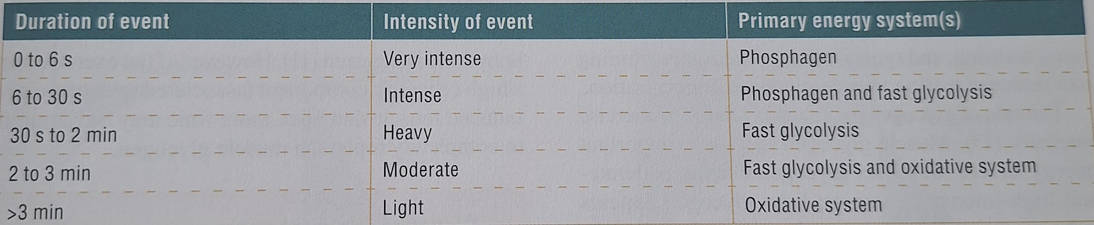
- Dynamic muscle actions, such as a complete repetition of a weight training exercise, use more metabolic energy and typically deplete phosphagens to a greater extent than do isometric muscle actions, such as arm wrestling, in which there is no visible shortening of the muscle.
- Supplemental strategies can also be used to increase the intramuscular repletion of the phosphagen system. Creatine, a naturally occurring organic compound found primarily in red meat, milk, and seafood, is one of the most commonly used nutritional ergogenic agents.
- Some muscle glycogen resynthesis will occur even in the absence of ingested carbohydrate; however, to optimize intramuscular glycogen stores, carbohydrate ingestion during the postexercise period is considered critical. Repletion appears to be optimal if 1.2 g of carbohydrate per kilogram of body weight is ingested approximately every two hours after exercise.
- Glycogen is a vital energy source, particu- larlv for high-intensive exercise. Glvcogen storaae within the bodv is limited to about 500 a (about 2,000 kcal), and glycogen depletion is associated with fatigue. Glycogen repletion can occur rapidly but may take up to 24 hours for complete resynthesis.
- Oxygen uptake (or consumption) is a measure of a person's ability to take in and use oxygen. The higher the oxygen uptake, the more fit the person is thought to be.
- Postexercise oxygen uptake has been termed the oxygen debt, or the excess postexercise oxygen consumption (EPOC). The EPOC is the oxygen uptake above resting values used to restore the body to the preexercise condition.
- The main thing to remember is that the higher the exercise intensity the shorter the amount of time the exercise can be performed and the greater the reliance on the fastest ATP-producing energy systems, which also have the least capacity. The opposite is also true; the lower the exercise intensity, the longer that exercise can be performed, and the greater the reliance on the slower ATP-producing energy systems. In this case, ATP can be produced as long as the body has a good supply of muscle glycogen and fatty acids.
- Rest periods between sets and exercises also play a factor because longer rest periods allow for more complete ATP resynthesis from the phosphagen system.
- All three energy systems have the capacity to adapt based on the principle of training specificity. Challenging the glycolytic system via repeated bouts of moderate- to high-intensity activity, for example, will alter lactate production and result in an improvement in lactate threshold (LT).

Chapter 4 - Biomechanics
- Functional anatomy is the study of how body systems cooperate to perform certain tasks.
- Biomechanics is a field of study that applies mechanical principles to understand the function of living organisms and systems.
- Mechanics is the branch of physics that deals with the effects of forces and energy on bodies.
- Many of the terms defined and applied here have specific meanings, sometimes different from the meanings of the terms as used by the lay public.
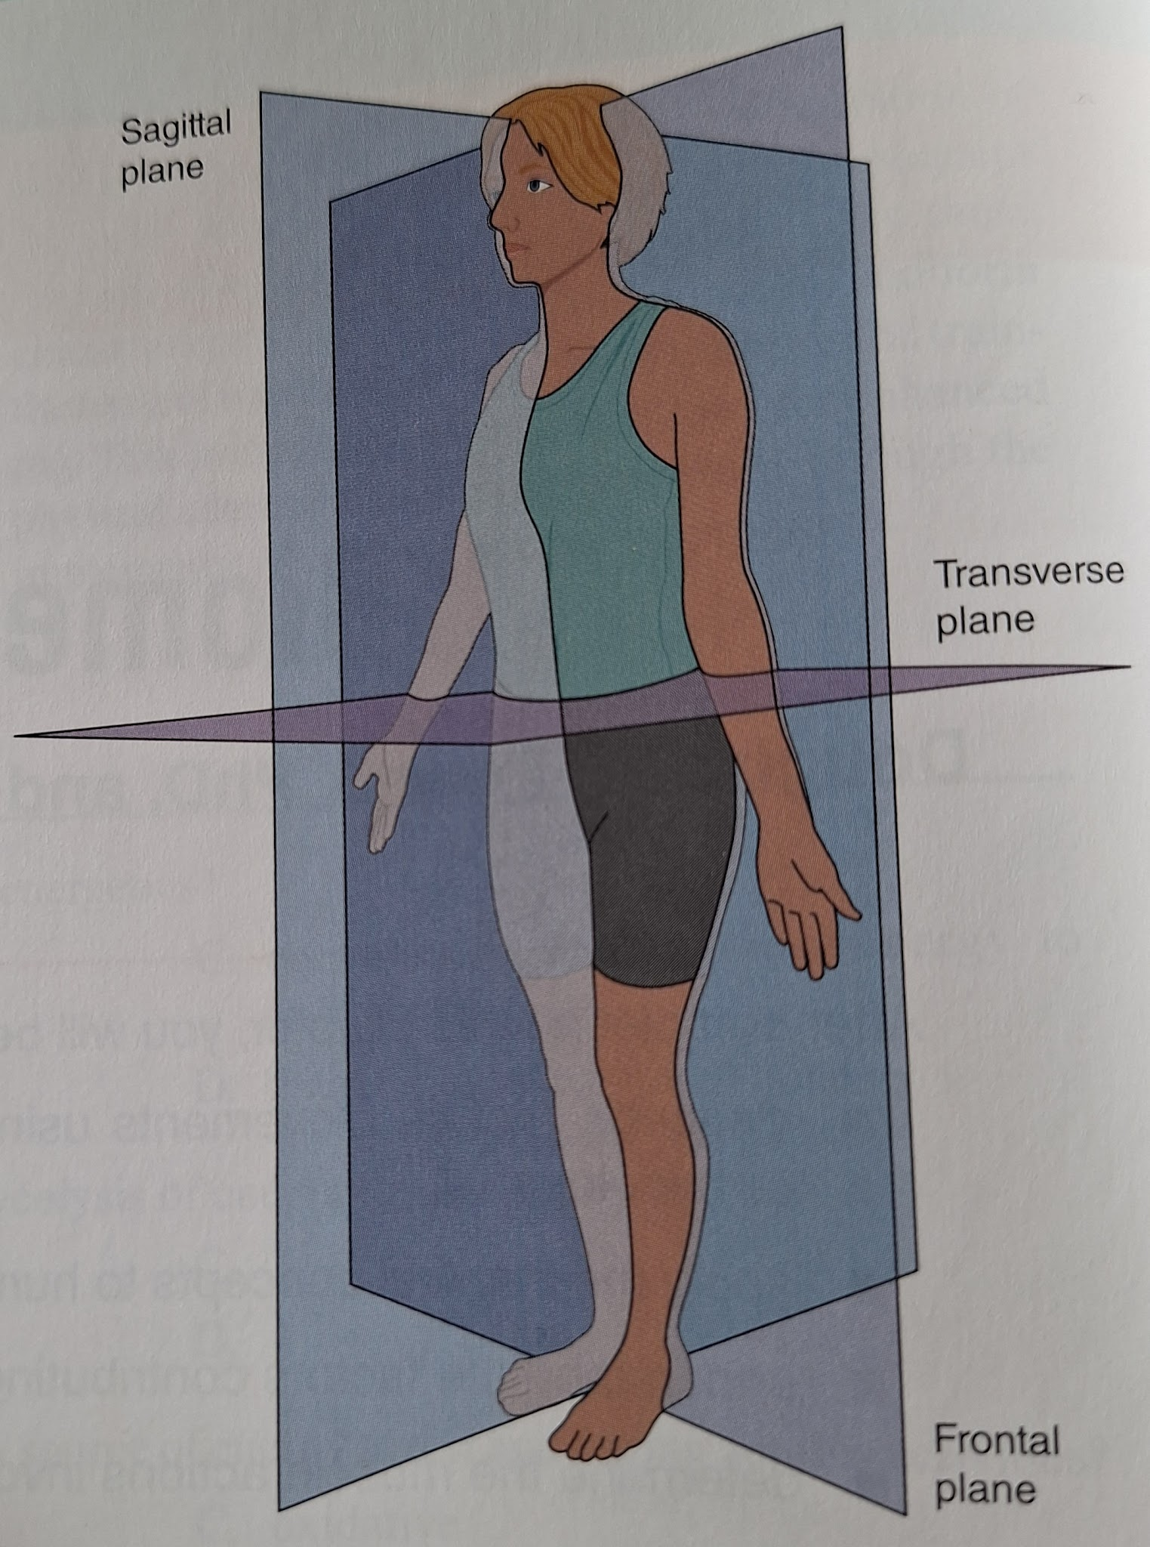
- The study of movement from a descriptive perspective without regard to the underlying forces is termed kinematics.
- In contrast to kinematics, movement assessment with respect to the forces involved is called kinetics.
- Force is the fundamental mechanical element that can produce, change, or stop the motion of a body.
- Momentum characterizes a body's quantity of motion Mechanically, linear momentum is the product of mass (m) and velocity (v).
- To change (either increase or decrease) momentum a mechanical impulse must be applied. Impulse is the product of force (F) multiplied by time (t).
- Torque (T), or moment of force (M). is the rotational effect of a force about an axis.
- Torque creates an angular acceleration similar to the way force creates a lineal acceleration.
- Rarely will a single torque be applied in human movement. Therefore, movement is the result of the net torque, or the sum of all internal and external torques acting on a limb.
- Human movement is produced and controlled by the sum of all internal (muscle and external (gravity, loading) forces acting on limb segments.
- A lever is defined as a rigic structure, fixed at a single point (fulcrum, or axis) to which two forces are applied.
- One of the forces is commonly termed the applied force also effort force) and is produced by active muscle The other force, referred to as the resistance force also load), is produced by the weight being lifted (i.e.. gravity) or another external force being applied (e.g.. friction, elastic band).
- Joints in the human body are predominantly third-class levers. with some first-class levers and relatively few second-class levers.
- Mechanical advantage, which is defined as the ratio resistance force : applied force.
- Mechanically, work has a specific definition related to how much force is applied anc how far an object moves. Mechanical work (W) is defined as the product of force (F) times the distance (d) through which an object moves.
- The rate of work, termed mechanical power (P). is calculated as the amount of work (W) divided by the time (t) needed to do the work: P = W / t
- To produce powerful movements and to train for power, a person must generate high forces while moving at a high rate of speed.
- Mechanical energy, however (as is the case with mechanical work). has a specific meaning: the ability, or capacity, to perform mechanical work.
- In biomechanical terms. efficiencv refers to how much mechanical output (work) can be produced with use of a given amount of metabolic input (energy). The ratio of mechanical output to metabolic input defines the efficiency of a movement task. Human skeletal muscle, for example, is only about 25% efficient.
- Muscle tissue has four distinguishing characteristics: excitability, the ability to respond to a stimulus; contractility, the ability to generate a pulling force (also called tension); extensibility, the ability to lengthen or stretch; and elasticity, the ability to return to its original length and shape when the force is removed.
- The fibers within muscle are arranged in a variety of ways. In some muscles (e.g., biceps brachii, semitendinosus), the muscle fibers run parallel to a line between the muscle's origin and insertion (line of pull). In other muscles, the fibers are arranged at an angle (normally <30 degrees) to the line of pull.
Other muscles, such as the pectoralis major and latissimus dorsi. have a radiating fiber arrangement.
- Resistance training cannot change a muscle's architecture.
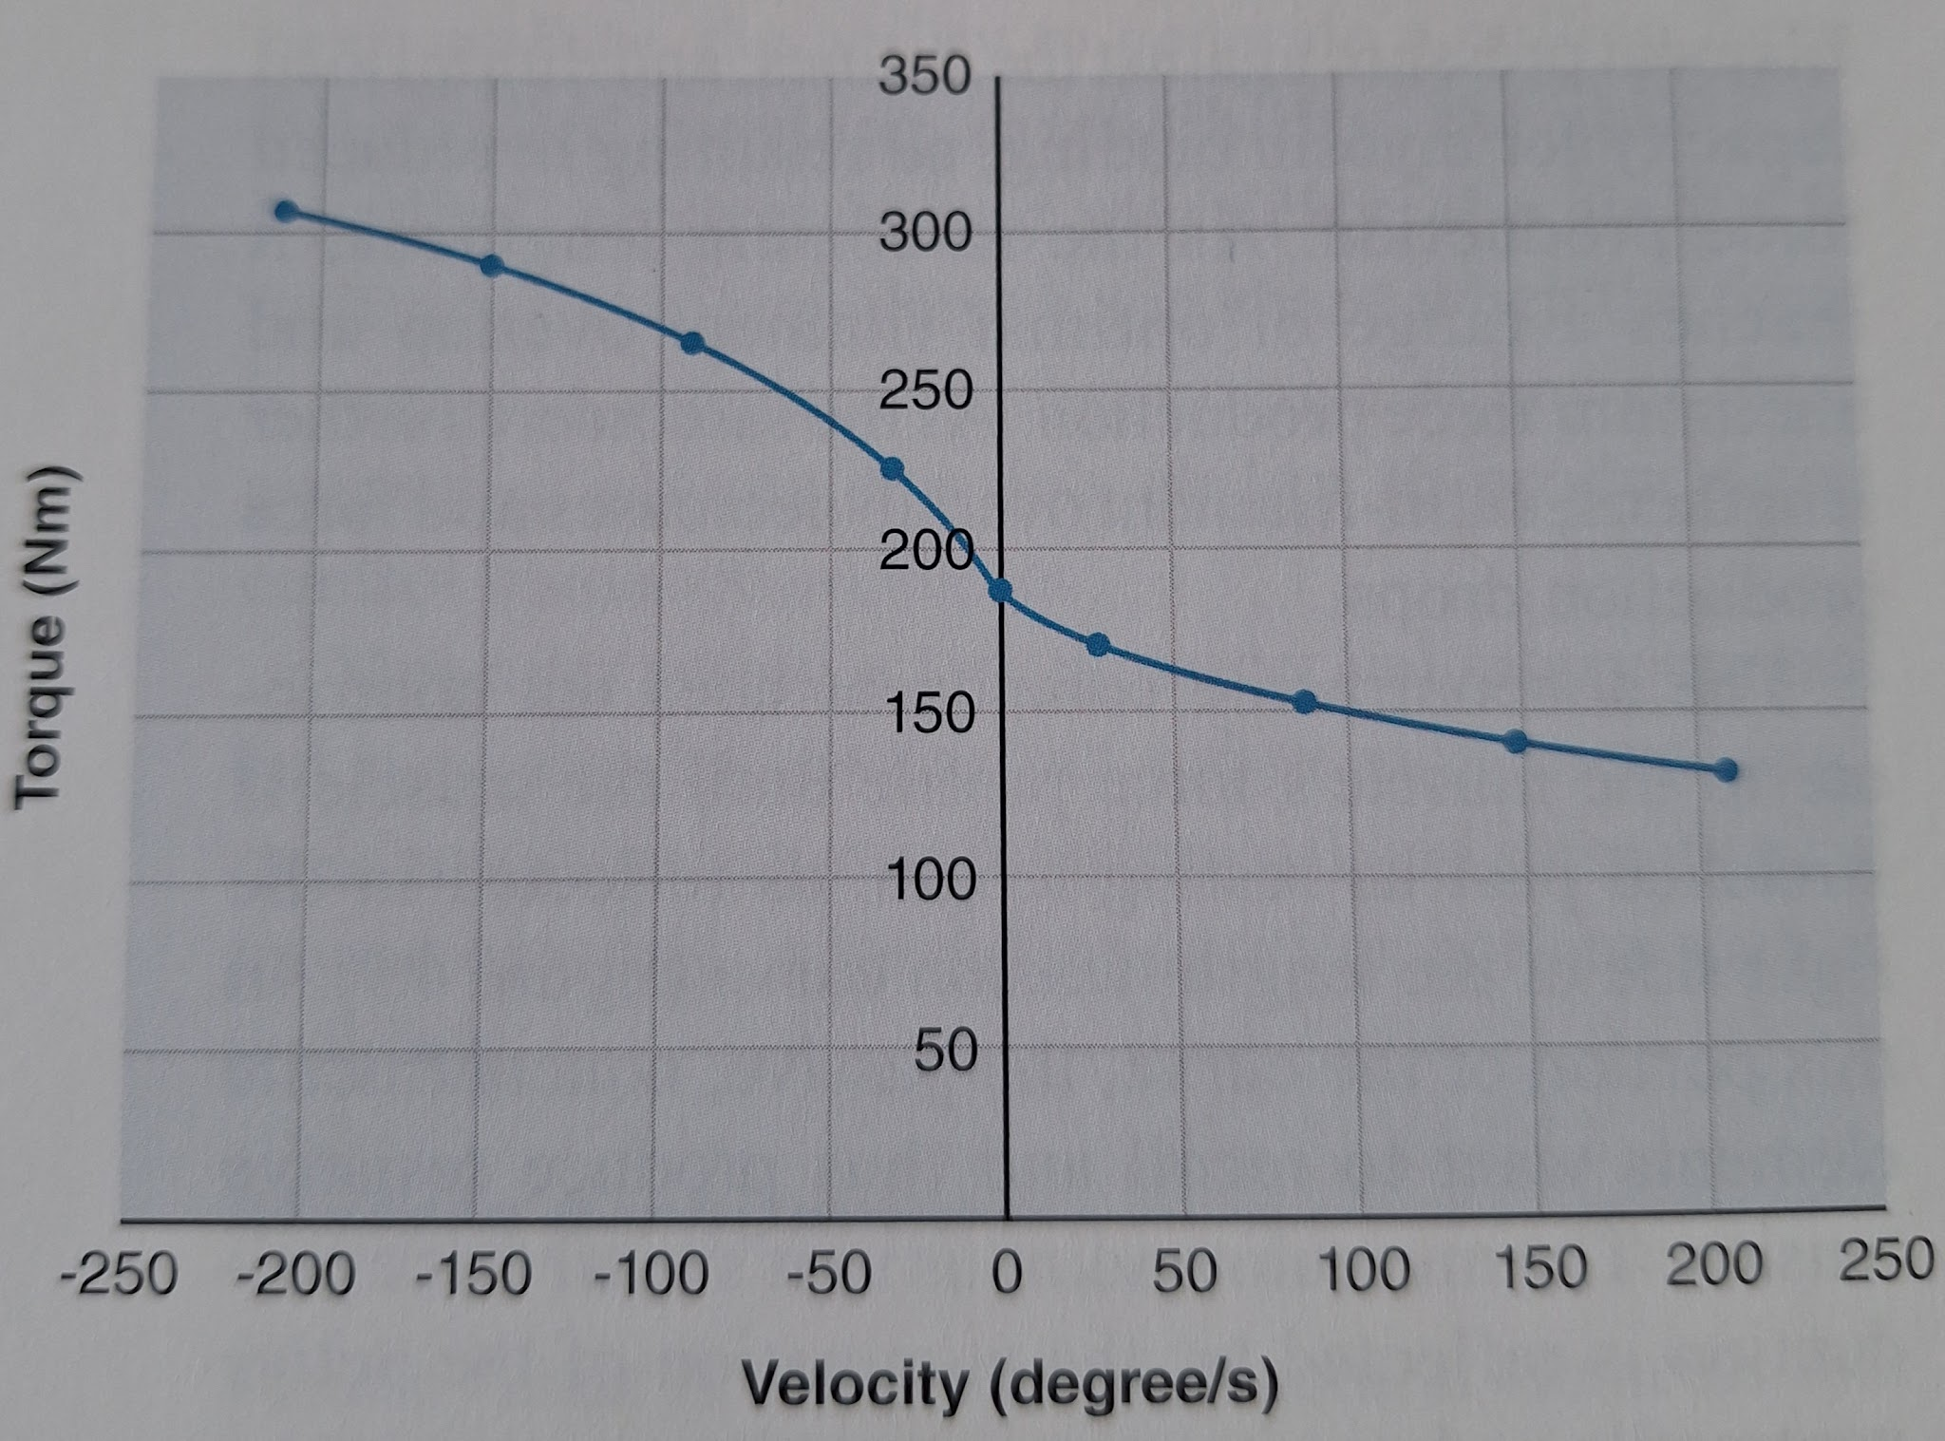
- The larger forces generated with eccentric muscle action form the basis for "negative” training. When negatives are performed, either the resistance is increased during the lowering phase or some form of assistance is given during the raising phase. This type of training is an effective means of increasing strength and hypertrophy.
- The maximum force production capability of a muscle is proportional to its cross-sectional area.
- The force of contraction per unit area is known as specific tension. Research on isolated motor units has shown that fast-twitch muscle fibers have a higher specific tension (22 N/cm2) than slow-twitch muscle fibers (15 N/cm²).
- Both intramuscular and intermuscular coordination play a role in the maximum amount of force a muscle can produce. Intramuscularly, or within a muscle force can be increased by increasing the firing frequency of the motor unit, increasing the number of motor units recruited. and recruiting progressively larger motor units. Intermuscularly. or among more than one muscle. force can be increased by increasing the activation of the agonists and synergists, decreasing the activation of the antagonists, or both. During the first few weeks of training, much of the improvement in strength gains is attributed to these neural adaptations (24) because the increase in strength gains exceeds the increase in muscle fiber. Personal trainers need to be cognizant of this fact. A client may be greatly encouraged by large initial increases in strength but become discouraged with the slower rate of improvement that follows. In addition to providing encouragement, the personal trainer should educate the client about how the slower gains due to hypertrophy will result in enhanced strength and improved physical appearance.
- Rate of force development can be defined as the time rate of change of force, or the ratio of the change in force over the change in time.
- Plyometric training enhances RFD by involving the stretch-shortening cycle (SSC). The SSC requires an eccentric muscle action immediately followed by a concentric muscle action.
- Moment arms can vary considerably among individuals. This may help explain why two people can have similar muscle sizes but different levels of strength.
- With respect to human performance, strength generally refers to the ability to exert force.
- Expressing strength is usually limited to the amount that can be lifted through the weakest point in the range of motion, termed the sticking point (or sticking region).
- The selection of open versus closed kinetic chain exercises is important for transfer ability of an exercise to human movement performance; however, there is no exact consensus on their respective definitions.
- An open chain is one in which movement of one joint is independent of the other joints in the chain, while a closed chain is one in which movement of one joint causes the other joints in the chain to move in a predictable manner.
- Step-by-step algorithm for determining muscle involvement and action for any joint movement:
- Step 1: Identify the joint movement (e.g., abduction, flexion) or position.
- Step 2: Identify the effect of the external force (e.g., gravity) on the joint movement or position by asking the question "What movement would the external force produce in the absence of muscle action (i.e.. if there were no active muscles)?”
- Step 3: Identify the type of muscle action (concentric, eccentric. isometric) using the answers from step 1 (#1) and step 2 (#2).
- Step 4: Identify the plane of movement (frontal. sagittal, transverse) and the axis of rotation. The purpose of this step is to identify which side of the joint the muscles controlling the movement cross (e.g., flexors cross one side of a joint, while extensors cross the opposite side)
- Step 5: Ask. "On which side of the joint axis are muscles lengthening and on which side are they shortening during the movement?'
- Step 6: Combine the information from steps 3 and 5 to determine which muscles must be producing or controlling the movement.
- When prescribing and evaluating specific exercises, personal trainers should keep in mind that variations in exercise technique can affect muscle recruitment.
- Understanding which muscles are controlling a movement, and how modifying the exercise affects those muscles, is key in selecting appropriate exercises for a given goal.
- Training to improve motor qualities (such as strength, power, or muscular endurance) requires the application of a progressive overload over time.
- Resistance may be classified as one of three types:
- Constant
A constant resistive force does not change throughout the range of motion. Free weights and certain machines provide a constant-resistance force.
A free weight is any object that has a fixed mass and no constraints on its motion. By this definition. barbells. dumbbells. medicine balls. and a person's body (or parts of it) are all considered free weights.
The resistance of a constant weight will be the greatest when the moment arm is the longest.
Unlike a free weight, a machine constrains the motion of the resistance in some way. The path of the resistance can be linear (as with a leg press or Smith machine) or angular (e.g., knee extension or knee curl machine).
- Variable
A variable resistive force will increase or decrease (or both) throughout the range of motion. Certain machines, elastic bands and tubes, and chains attached to the end of a barbell have this property of variable resistance.
Examples are cam-based weight-resisted machines (Since not everyone has the same strength curves for a given joint, their goal was met with limited or no success).
Elastic resistance is not constant but increases proportionally with the distance the material is stretched beyond its resting length. Thus, resis- tance is minimal at the beginning of the exercise and increases as the movement is performed.
Elastic materials should be replaced frequently to ensure consistent loading.
With chains attached to the bar, most of the chain's weight is supported by the floor at the bottom of the movement. As the bar rises more of the chain lifts off the floor, progressively increasing the resistance.
- Accommodating
An accommodating resistive force will vary depending on the force applied to it. In other words, accommodating resistances provide resistance that is proportional to the client's effort. Accommodating resistances include isokinetic dynamometers flywheels, and fluid resistance.
Isokinetic devices control movement speed to provide, at least nominally, constant angular velocity.
Flywheels require the person to pull a cord, which in turn rotates a disk. Resistance is provided by the rotating disk through a mass located some distance away from the disk's axis of rotation. The flywheel's resistance increases as its angular acceleration increases. In other words, the harder one pulls on the cord, the greater the resistance to the motion provided by the flywheel.
Hydraulic and pneumatic devices that use some sort of piston to push or pull a fluid (liquid for hydraulic and gas for pneumatic) through a cylinder and movements performed under water have similar biomechanicar properties. The resistance the machine provides to the user increases with the velocity of the movement (quadratically).
A benefit of this type of resistance is there is no external weight that can gain momentum. and thus the client can use very high velocities without a reduction in the force being applied.
- Performing exercises in the water can be used to create exercises that are buoyancy supported, buoyancy assisted, or buoyancy resisted.
- Selection of the tvpe of resistance - constant, variable, or accommodating - is an important factor in designing a safe and effective exercise program.

Chapter 5 - Responses and Adaptations to Resistance Training
- Four prominent themes resonate throughout the chapter, and personal trainers should appreciate these when working with clients:
- Whether a client is novice or advanced, each resistance training bout (if designed properly) is a substantial stressor to the body.
- Progressive overload during a training period ensures that the body is adequately stressed. The implementation of progressive overload involves manipulating training volume, intensity, or frequency in order to apply continued stress to the body.
- Chronic training adaptations occur in phases.
The initial and obvious adaptation to resistance training is an increase in strength (within the first month).
Visual changes in muscle mass or tone occur as soon as one to two months after initiating a regimented program.
Discernable improvements in bone mineral density occur over several months to years.
This is critical to appreciate given that each client may have different motivations for training.
- Every client will respond differently to training.
- Acute responses are changes that occur in the body during and shortly after an exercise bout. Chronic adaptations are changes in the body that occur after repeated training bouts and that persist long after a training session is over. The summation of acute responses to each training bout catalyzes chronic training adaptations in all the major organ systems (e.g., musculoskeletal, cardiovascular, nervous, endocrine, immune).
- Performing exercises to failure during each training session over a 10-week period may result in artificial strength plateaus.
- Programming should not have clients perform lifts to failure during every set, and the program should contain interspersed recovery blocks (or deload periods).
- Improvements in strength associated with the first couple of months of resistance training are primarily due to neurological adaptations.
- It is critical for personal trainers and clients to appreciate that only 10% to 20% of individuals are low responders, so this is not a common phenomenon. Low responders may eventually gain a considerable amount of muscle mass with years of training.
- Muscle hypertrophy (i.e., muscle growth) is usually not measurable (although it is still occurring) until four to eight weeks after the initiation of a resistance training program.
- Acute responses to training:
  - Neurological Changes:
    - Increase EMG amplitude (voltage change on the sarcolemma).
    - Increase the number of motor units recruited.
    - Recruitment of motor units for force production follows the size principle, meaning that lower-threshold motor units are recruited at lower force levels and both lower- and higher-threshold motor units are recruited at higher force levels.
  - Muscular Changes:
    - Increase hydrogen ion concentration
    - Increase inorganic phosphate concentration
    - Increase ammonia levels
    - No change or slight decrease of ATP concentration
    - Decrease Creatine Phosphate concentration
    - Decrease glycogen concentration
    - The acute changes in muscle cells include an accumulation of metabolites (i,e., substances [such as lactate] formed during metabolic reactions) and depletion of fuel substrates.
    - All of these metabolites have been studied as potential causes of muscle fatigue, but researchers are now beginning to appreciate their roles in promoting long-term adaptation.
  - Endocrine Changes:
    - Increase epinephrine concentration
    - Increase cortisol concentration
    - Increase testosterone concentration
    - Increase growth hormone concentration.
    - Epinephrine binds to adrenergic receptors to increase fat and carbohydrate breakdown by the cell so that more ATP will be available for muscle contraction.
    - As a general rule, bouts that have higher volume and shorter rest periods elicit stronger endocrine responses than do bouts with lower volume and longer rest periods, although the differences between protocols may diminish with prolonged training. Similarly, large muscle mass exercises promote greater increases in anabolic hormones than do small muscle mass exer- cises. Other factors such as sex and age can affect the acute endocrine response.
- Small muscles typically depend more heavily on firing rate to control force output, while large muscles tend to depend more heavily on recruitment.
- Hormones are blood-borne molecules that are produced in the endocrine glands. There are two primary types of hormones: protein and peptide hormones and steroid hormones. Two examples of protein and peptide hormones are growth hormone and insulin. Steroid hormones are all derived from a common precursor (cholesterol) and include hormones such as testosterone (the primary male sex hormone) and estrogen (the primary female sex hormone).
- To facilitate a biological response, hormones must bind to a hormone-specific receptor in a target tissue. For example, testosterone affects muscle cells at the molecular level by binding to androgen receptors.
- Chronic Adaptations to Resistance Training:
  - Neurological Changes:
    - Likely increase EMG amplitude during MVC
    - Increase motor unit firing rate
    - Decrease cocontraction. Refers to the simultaneous activation of an agonist and an antagonist during a motor task.
    - Likely increase motor unit recruitment
    - The influence of neural factors on strength gains is believed to be dominant in the early phases of a training program (one to two months), and thereafter hypertrophy begins to significantly contribute to strength gains.
    - Much of the improvement seen early in training is likely due to improvements in performing the resistance exercises. However, some evidence suggests this effect is partly due to changes in motor unit recruitment and firing rate.
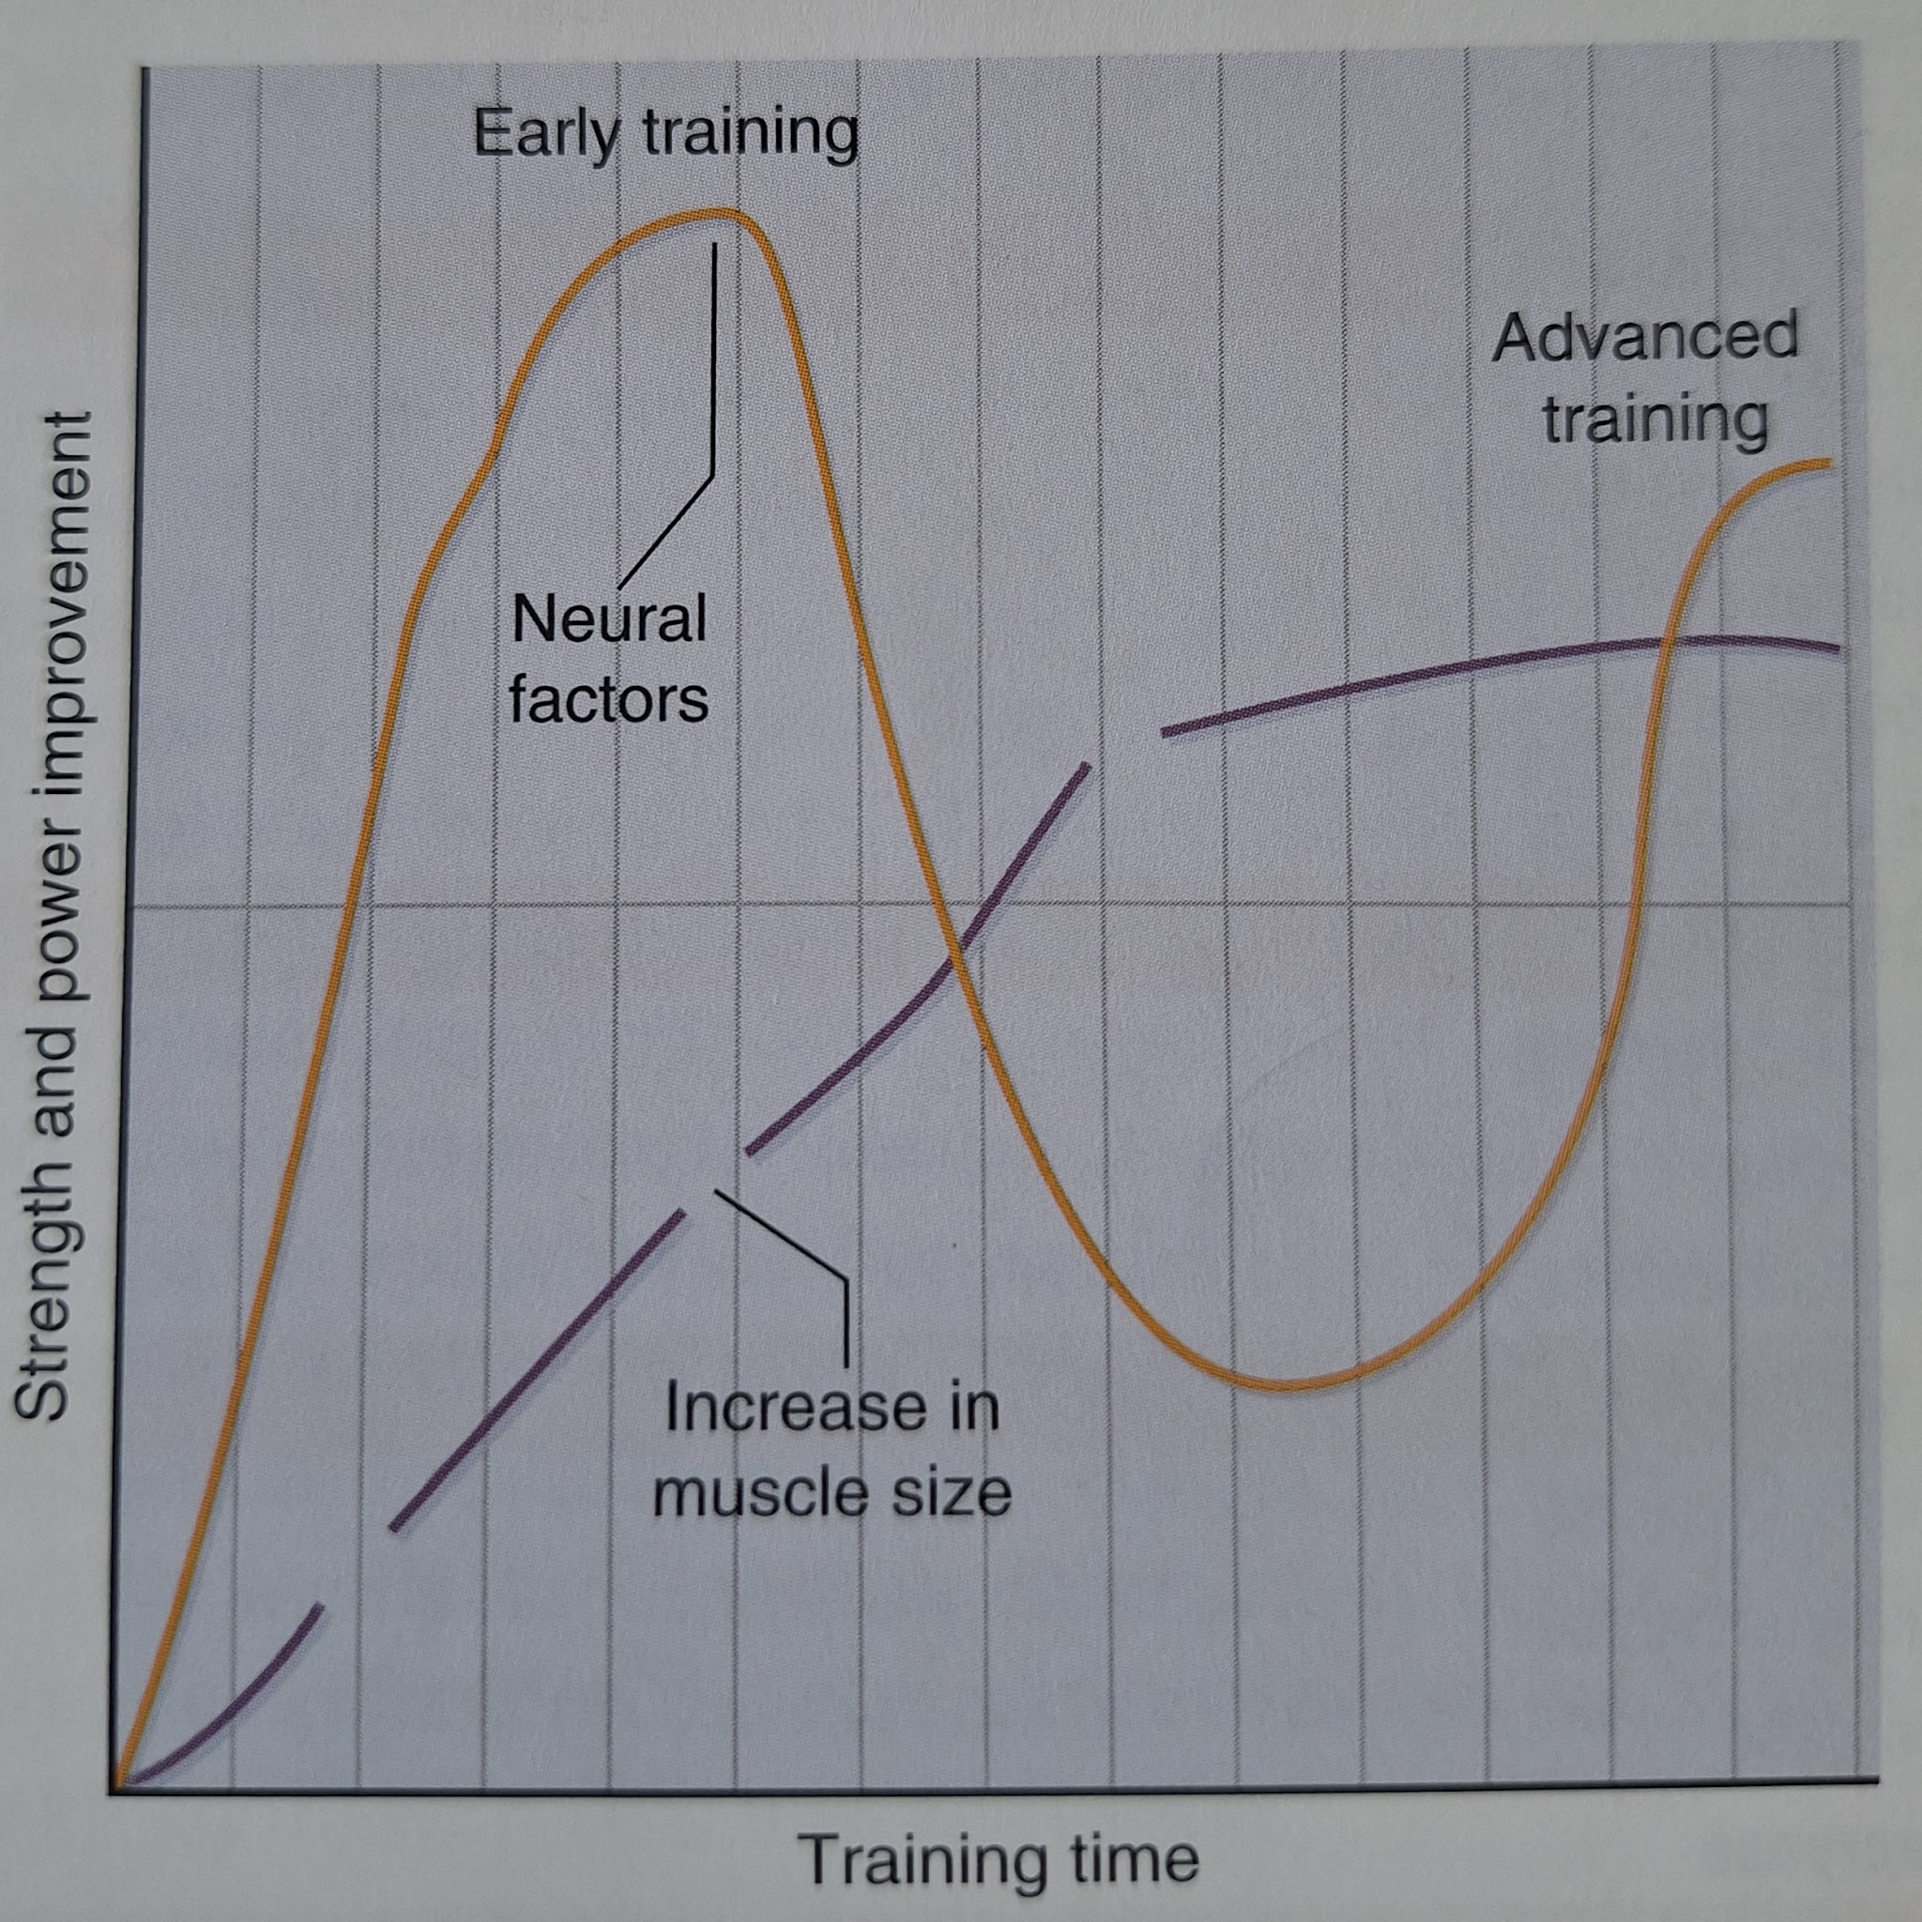
    - The contribution of neural factors to strength improvement has also been inferred from observations that unilateral resistance training improves strength in the untrained limb (i.e. cross-education effect), as well as from observations that isometric resistance training at one joint angle results in strength increases that are larger at the trained angle than at other joint angles.
  - Muscle Tissue Changes:
    - The most obvious adapta- tion in skeletal muscle is hypertrophy in the form of increased muscle size (cross-sectional area and volume)
    - Resistance training also increases the cross- sectional area of both type I and type II muscle fibers. However, type II fibers typically show a greater degree of hypertrophy compared with type I fibers (41). and type II fibers are also susceptible to a greater degree of atrophy following detraining.
    - The primary adaptation of skeletal muscle to long-term resistance training is hypertrophy, or increased cross-sectional area of the muscle fiber, resulting in increased force and power production capability.
    - With respect to muscle fiber types, resistance train- ing induces a fiber subtype shift from type IIx to type IIa muscle fibers.
    - Some researchers have posited that years of resistance training may eventually promote the transition of some type I fibers to type II fibers. In support of this argument, several human biopsy studies have revealed that type IIa and IIx fibers are more prominent in individuals who engage in long-term resistance training, whereas type I fibers are prominent in individuals who engage in long-term aerobic endurance training.
    - A bout of resistance training also increases the rate of muscle protein degradation, but this response is less robust in magnitude as an individual becomes more trained.
    - Increased protein degradation with a bout of resistance exercise is likely a consequence of muscle damage that has occurred during training via primarily eccentric contractions,and there is some speculation that the damage may be a stimulus for hypertrophy.
    - There is evidence, however, that concentric-only training causes skeletal muscle hypertrophy.
    - In addition to increasing the contractile protein content of skeletal muscle, resistance training appears to increase cytoskeletal and structural proteins. These proteins help give skeletal muscle cells shape and structural integrity.
  - Skeletal Changes
    - The greater the bone mass before menopause, the less severe the consequences of loss of bone mass.
    - Resistance training may lead to decreased risk for osteoporosis fractures, and falls in later life.
  - Tendon and Ligament Changes
    - Research has consistently shown that tendons can adapt to the loads applied during training, but there is little data on the specific effects of training on ligaments.
  - Cartilage Changes
    - Resistance and aerobic training are currently accepted as an effective treatment for osteoarthritis (OA patients).
    - Longitudinal studies investigating the effect of resistance exercise on healthy cartilage are limited and do not support morphological improvement above normal levels.
    - With significant loss of cartilage and function found during periods of immobilization, the data indicate that the primary benefit of physical activity is to either maintain healthy cartilage thickness and composition or minimize loss from genetic predisposition.
  - Metabolic Changes
    - Research has shown that chronic resistance training induces a variety of cellular changes that affect the metabolism of skeletal muscle.
  - Endocrine Changes
    - Although resistance training can cause large changes in hormone concentrations during and after a bout of training, the long-term effects of resistance training on resting hormone concentrations are less clear.
    - Overreaching or overtraining can cause changes in hormone concentrations that are different from those seen during normal training situations.
  - Cardiorespiratory Changes
    - Resistance training places a markedly different stress on the cardiorespiratory system than does aerobic endurance exercise such as running or cycling, and therefore the effects on the cardiorespiratory system are quite different.
    - Resistance training typically increases VO2 max in older subjects (>60 years). Moreover, the authors speculated that resistance training better increases VO2 max in both younger and older individuals with low aerobic fitness levels. It is important for personal trainers to understand that aerobic fitness adaptations from resistance training are likely dependent on the age and pre-existing fitness levels of the client.
    - Increasing aerobic endurance capabilities requires aerobic endurance-specific train- ina to achieve optimal results: however. resistance training can augment aerobic endurance performance and running effi- ciency by increasing muscular strength and power.
    - Despite the lack of improvement in skeletal muscle cellular aerobic function. normal increases in muscle size (i.e., hypertrophy) with resistance training do not reduce muscular endurance. On the contrary increases in muscle size and strength due to resistance training increase local muscular endurance.
  - Body Composition Changes
    - For the personal trainer, the model that best relates to the needs of clients is the two-component model, which segregates the body into fat mass and fat free mass (FFM). The FFM is composed of tissues such as muscle, bone, and connective tissue.
    - Increases ir FFM independent of changes in fat mass will decrease body fat percentage.
    - According to several studies, resistance training increases FFM and decreases body fat percentage in men, women, and the elderly.
    - Long-term resistance training may decrease fat mass over time given that the act of lifting weights expends calories to fuel muscle contraction. Resistance training also elevates calorie expenditure during the recovery period between training sessions in order to replenish fuel substrate in muscle used during training.
    - Although some studies have shown that resistance exercise can increase resting metabolic rate, others have not.
- Osteoporosis is the consequence of long-term net demineralization of bone.
- Factors that influence adaptations to resistance training:
  - Specificity
    - The effects of exercise training have been shown to be highly specific. That is, the body adapts to exercise in such a way that it can perform optimally in relation to a particular type of exercise stressor, but not necessarily other types of exercise.
    - It appears that the effects of resistance training are specific to the muscle action mode in which the exercise was performed.
    - Resistance with respect to the velocity with which muscle actions have been performed in training.
  - Sex
    - Much of the difference between the sexes is attributable to differences in body size and body composition. Specifically, men tend to be larger than women, and the associated differences in muscle mass contribute to strength differences. Similarly, women tend to have a higher percentage of body fat than men: therefore, most women have less muscle per pound of body weight.
    - Differences in body size and body composition are largely driven by differences in hormone levels between men and women, most notably testosterone and estrogen.
    - Sex-related differences in strength are larger in the upper body than in the lower body.
    - The force production capability of a given amount of muscle is not affected by a person's sex.
  - Age
    - Muscle quality declines with age.
    - As individuals aae. thev see declines in both their ability to produce force and their ability to produce force rapidly.
    - It is well recognized that resistance training can increase muscle mass and strength in persons who are elderly.
  - Genetics
    - Predisposition toward certain traits (e.g., body fatness or even certain behaviors) has been largely attributed to genetics.
    - [Brief explanation of how genes work]
    - Individual genetic potential in regard to gaining muscle mass, increasing strength, or losing fat is largely dictated by slight differences in genetic code, or gene variants, that exist across multiple genes.
- The age-related loss of muscle mass is referred to as sarcopenia.
- Although physical adaptations are best brought about by increases in training volume and intensity, at certain points in a training program, more is not better.
- Inappropriate levels of volume or intensity can lead to a phenomenon known as overtraining. As the term suggests, overtraining is a condition in which an individual trains excessively, resulting in staleness and general fatigue.
- It appears that the two primary contributors to overtraining in response to resistance training are too much intensity and too much volume.
- Individuals may fall into either or both of two overtraining scenarios (both scenarios are common):
  - Overuse injury of a joint or muscle.
  - Overtraining of the body, which can lead to changes in mood profile, lethargy, and premature strength plateaus.
- Effective program design includes increasing and decreasing the total volume of the workout and using the concepts of periodization to plan changes in volume. intensity, and recovery.
- Overreaching: some programs use short periods of overwork followed by rest or reduced training to achieve the benefits of a rebound, or supercompensation, in physical strength and power.
- Symptoms of overtraining:
  - Plateau followed by decrease of strength gains
  - Sleep disturbances
  - Decrease in lean body mass (when not dieting)
  - Decreased appetite
  - A cold that just will not go away
  - Persistent flu-like symptoms
  - Loss of interest in the training program
  - Mood changes
  - Excessive muscle soreness
- Detraining refers to the physiological and performance adaptations that occur when an individual ceases an exercise training program: there is a loss of muscle mass (i.e., atrophy), and the changes in neurological function (e.g., recruitment, rate coding, cocontraction) that occurred with training dissipate. Thus, the muscle becomes weaker and less powerful. Skeletal muscle atrophy appears to occur faster in the fast-twitch muscle fibers.
- Short-term detraining (14 days) appears to have little effect on muscular strength and explosive power, suggesting the effects are relatively slow.
- Given that the effects of detraining have been found to be significantly reduced with the incorporation of just one training session per week, clients with unexpectedly busy or difficult schedules may maintain a certain level of strength by training only once per week.
- Older individuals appear to require somewhat higher volumes for maintenance.
- Although resistance training is not a panacea, its effects are almost universally positive, and personal trainers should encourage all clients to engage in an appropriate level of resistance training.

Chapter 6 - Responses and Adaptations to Aerobic Endurance Training
- Acute Responses to Aerobic Endurance Exercise:
  - Cardiovascular Responses
    - During aerobic exercise, an increased stimulation or excitation of the heart occurs in order to supply blood to the exercising skeletal muscle.
    - During exercise, a greater proportion of blood is shunted to the exercising skel- etal musculature where it is needed. At the same time, blood flow to other areas of the body, such as the splanchnic region, is decreased.
    - During aerobic endurance exercise involving large muscle groups, such as walking, jogging, cycling, and swimming, there is a linear increase in SBP in direct proportion to the exercise intensity and cardiac output and a negligible change in DBP.
    - Cardiac output, heart rate, stroke volume, mean arterial blood pressure, coronary artery diameter, and rate pressure product increase during exercise.
  - Respiratory Responses
    - Ventilation, breathing rate, tidal volume RER, and RQ increase during exercise.
  - Metabolic Responses
    - Increase oxygen consumption.
    - Increase arteriovenous oxygen difference.
    - Increase blood lactate.
    - Increase blood pH.
  - Endocrine Responses
    - In response to a bout of aerobic exercise, a major purpose of the endocrine system is to facilitate metabolism by maintaining the availability of carbohydrates (glucose) and fats (free fatty acids) that are needed to meet increased energy demands.
    - The increased glucagon release (and reduced insulin release) during acute exercise enhances fat breakdown in tissue (lipolysis) and triggers an increase in plasma fatty acids, making more fat available as a fuel for exercise.
    - Increase catecholamines.
    - Increase glucagon.
    - Increase insulin.
    - Increase cortisol for moderate to high intensity (>60% VO2 max). Decrease cortisol for low to moderate intensity.
    - Increase growth hormone.
    - These changes happen during exercise of high intensity.
    - Similar changes in these hormones also occur as exercise of moderate intensity continues for a long duration.
- Blood pressure (BP, mmHg) is the force exerted by the blood on the vessels to drive blood through the circulatory system. Measurements of systolic blood pressure (SBP) and diastolic blood pressure (DBP) represent the pressure exerted on the vessels during ventricular systole (contraction) and diastole (relaxation), respectively.
- The pancreas is an endocrine gland that plays a major role in acute exercise metabolism because of the production and release of glucagon and insulin.
- Chronic Adaptations to Aerobic Exercise:
  - Cardiovascular Adaptations
    - A training-induced reduction in heart rate has been shown to occur in two weeks, but depending on the intensity, duration, and frequency of training, may take up to 10 weeks. This response is believed to come from an increased parasympathetic influence. decreased sympathetic influence, and lower intrinsic heart rate.
    - Aerobic endurance training increases VO2max which is generally regarded as the single best measure of aerobic fitness.
    - [Here shows baseline and post training values for an initially inactive male, and a comparison with world-class aerobic endurance runner]

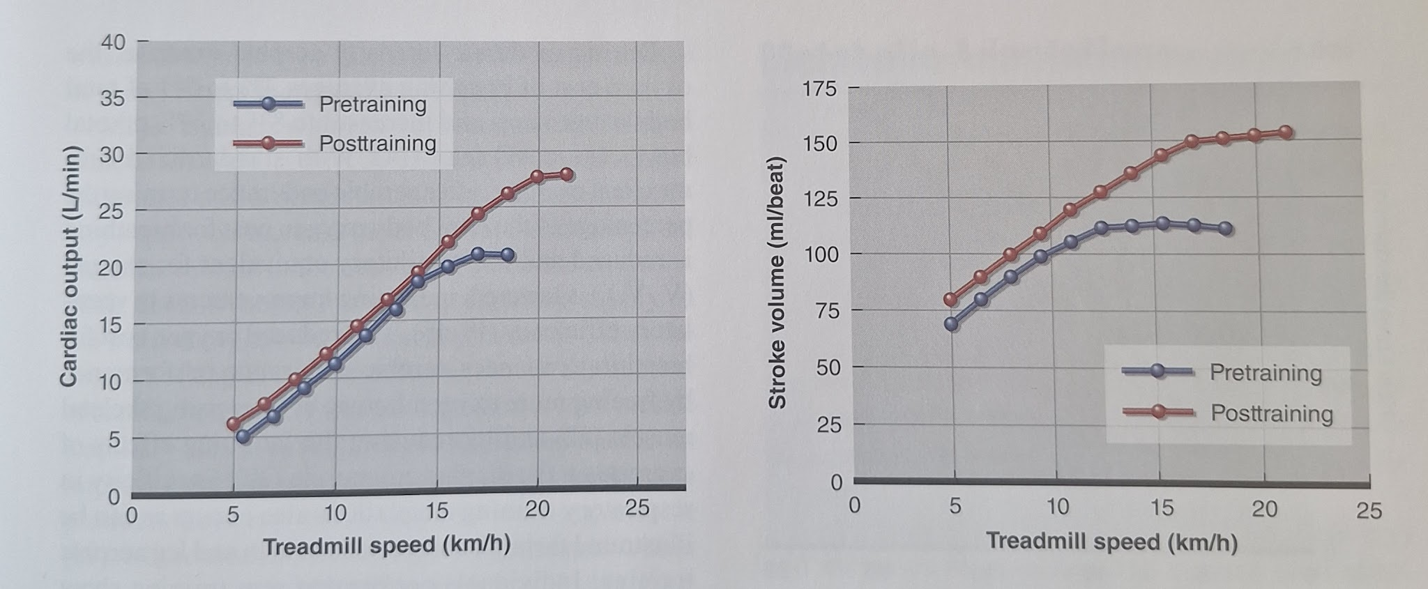

    - 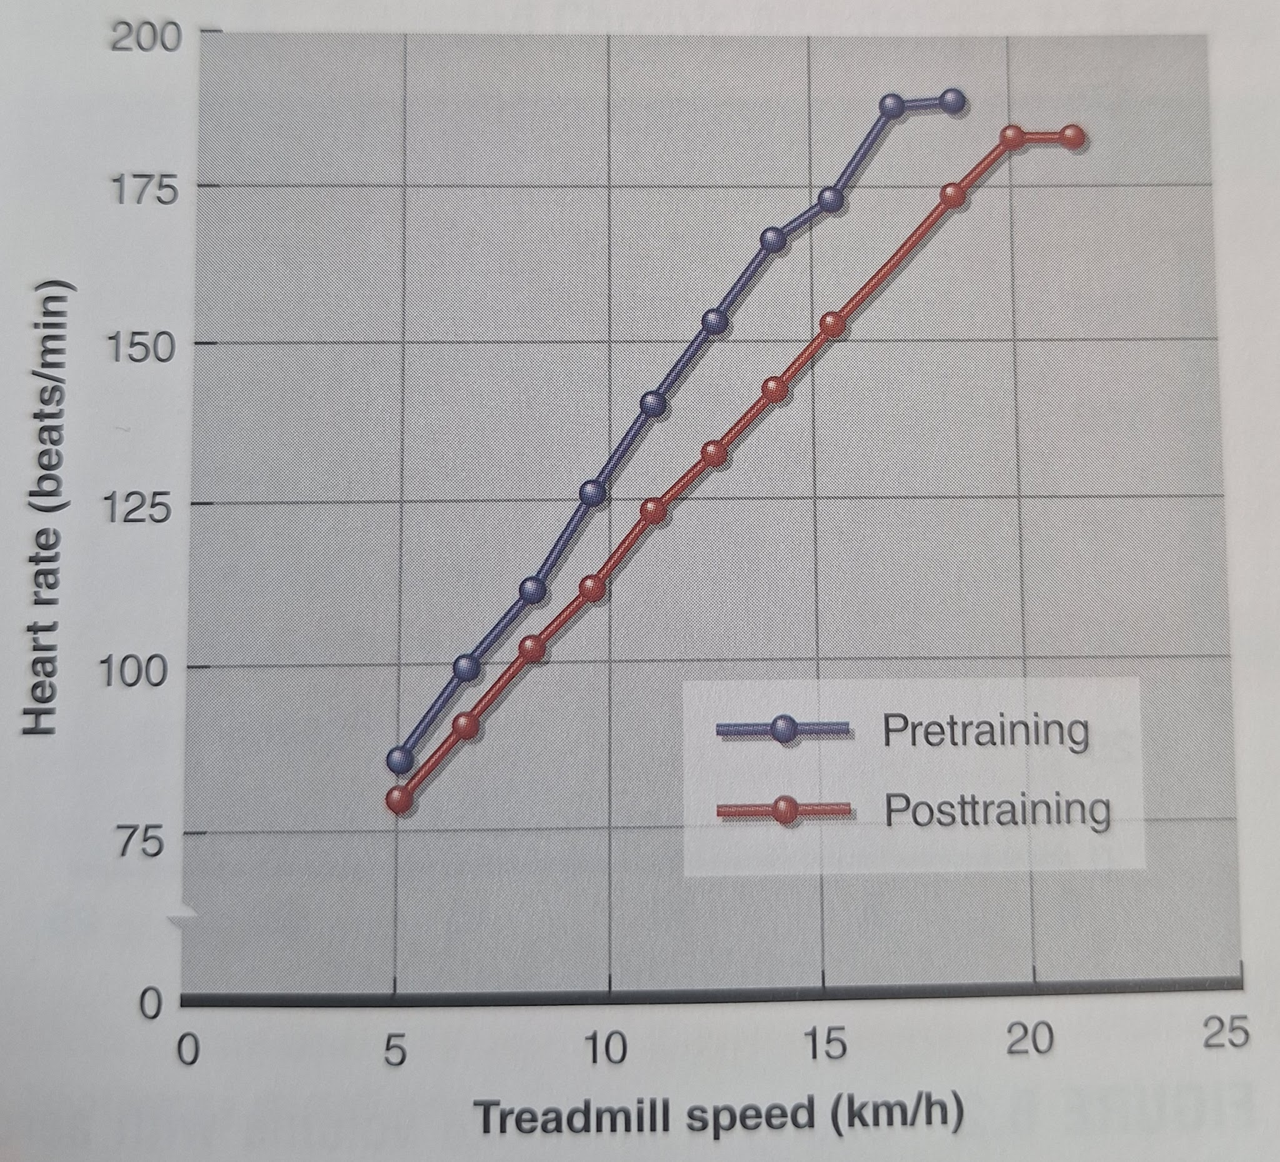
    - Aerobic endurance training reduces resting blood pressure in hypertensive individuals.
  - Respiratory Adaptations
    - Chronic aerobic training produces considerably less respiratory adaptation than occurs in the cardiovascular system and skeletal muscle.
    - For the great majority of healthy adults. the respiratory system is also not a limiting factor for performing maximal exercise.
    - Ventilatory efficiency improves with aerobic endurance training; pulmonary minute ventilation decreases during submaximal exer- cise and increases during maximal exercise.
  - Skeletal Muscle Adaptations
    - Chronic aerobic training does not affect muscle size at the macroscopic level (whole muscle) and has little, if any, effect at the microscopic level (specific fiber type cross-sectional areas).
    - Aerobic exercise recruits predominantly type I (slow-twitch) muscle fibers.
    - Small changes in fiber type distribution may occur in response to chronic aerobic training that shifts the distribution toward a larger percentage of more oxidative fibers.
    - Major changes with aerobic endurance training or skeletal muscle that directly relate to enhanced aerobic endurance performance include an increase in capillary supply, an increase in mitochondrial density, and an enhancement in the activity of oxidative enzymes.
    - With chronic aerobic endurance training, both the number and size of mitochondria increase.
    - In skeletal muscle, aerobic endurance training induces three major changes that directlv relate to enhanced aerobic endurance per- formance: an increase in capillary density: an increase in mitochondrial density; and an enhancement in oxidative enzyme activity.
  - Metabolic Adaptations
    - The major metabolic adaptations are an increased reliance on fat as energy and a coupled reduction in use of carbohydrates during submaximal exercise), an increase in lactate threshold, and an increase in maximal oxygen consumption. These changes translate into a greater capacity to perform at higher exercise intensities for prolonged periods.
    - Increase lactate threshold.
  - Endocrine Adaptations
    - Aerobic endurance training generally leads to a blunted response in hormone release at the same absolute level of submaximal exercise.
    - Favorable changes usually deteriorate within 72 hours of the last exercise session (note: so they're not chronic)
  - Bone and Connective Tissue Adaptations
    - Chronic aerobic training that incorporates moderate to high bone-loading forces can play a significant role in maximizing bone mass in childhood and early adulthood, maintaining bone mineral content through middle age, and attenuating bone mineral loss in older age.
    - Jogging, with its higher-intensity bone-loading forces, has been shown to attenuate bone loss with aging.
    - A combination of weight-bearing aerobic exercise (including jogging at least intermittently if walking is the main mode of exercise) and activities that involve jumping and resistance training (incorporating exercises that load all major muscle groups) is the recommended standard for maintaining bone health in adulthood.
  - Body Composition Adaptations
    - Decrease body mass
    - Decrease fat mass
    - Decrease fat free mass
    - Decrease % body fat
    - Evidence supports a dose-response relationship between the amount of the aerobic activity performed and the amount of weight loss. A benefit of aerobic endurance training regarding body composition is that it induces reductions in fat mass while having a minimal effect on (or preserving) fat free mass. Aerobic endurance training alone or in combination with an energy-restricted diet induces a greater loss in fat mass than an energy-restricted diet alone since the exercise promotes conservation of fat free mass
    - Health-related benefits of aerobic endurance exercise include enhanced insulin sensitivity, reduced body fat, and favorable effects on bone mineral density.
  - Performance Adaptation:
    - Increase aerobic endurance performance
    - No change in muscular strength
    - No change in vertical jump
    - No change in anaerobic power
    - No change in sprint speed
- Factors that influence adaptations to resistance training:
  - Specificity
    - The effects of exercise are all subject to the rule of specificity. This means that adaptations occur as a consequence of the training and in a fashion specifically related to the training. In short, if the exercise involves cycling, then the training adaptations will be most closely related to cycling performance. This is true also for running, swimming, or training on an ergometer or treadmill.
  - Genetics
    - There appears to be an absolute level that may not be exceeded based on genetic factors inherited from our ancestors.
    - There is a saying that the best training begins with choosing the right parents.
    - It has been estimated that genetic factors account for 20% to 30% of differ- ences between individuals in maximal aerobic capacity and for about 50% of differences in maximal heart rate.
  - Sex
    - The physiological changes due to aerobic exercise are similar for males and females.
    - Considering that females generally start an aerobic training program with smaller physiological values, they generally show smaller absolute adaptations than males but very similar relative (percent) adaptations.
  - Age
    - Females tend to reach their highest values for VO2max (L/min) between 12 and 15 years of age, while males do not reach their highest VO max until 17 to 21 years of age.
    - This period is followed by a plateau and then a gradual decrease as we age. Much of the decline can be negated through continued training regimens.
- Overreaching refers to short-term training, without sufficient recuperation that exceeds an individual's capacity.
- Overtraining syndrome is more serious and results from untreated overreaching that produces long-term impairments in performance and other conditions that may require medical intervention.
- Two types of overtraining have been theorized to exist: the difference is in the predominance of either the sympathetic or the parasympathetic nervous system. Apparently, aerobic endurance overtraining results predominantly from an excessive volume overload (parasympathetic dominant) whereas anaerobic or resistance overtraining (sym- pathetic dominant) primarily results from excessive high-intensity overload.
- These two types of overtraining have been reported to have different signs and symptoms, although performance decrements are a key common aspect of both.
- Common markers of aerobic endurance overreaching or overtraining:
  - Decreased performance
  - Decreased maximal oxygen uptake
  - Earlier onset of fatigue
  - General malaise
  - Loss of interest or enthusiasm for training
  - Disturbed psychological mood states (increased depression, anxiety, fatigue or decreased vigor, or a combination of these changes)
  - Increased muscle soreness
  - Decreased resting and maximal heart rate
  - Increased submaximal exercise heart rate
  - Decreased submaximal exercise plasma lactate concentration
  - Increased sympathetic stress response
  - Decreased catecholamine levels
- There are also highly individualized responses and symptoms for overreaching and overtraining that make them difficult for clients and personal trainers to recognize.
- A decline in performance coupled with one or more of the easily recognizable markers (i.e., fatigue. malaise, loss of enthusiasm for training, increased soreness) should lead to suspicion of this condition.
- How the body responds to detraining is analogous to how it responds to training. Once training is stopped. muscular endurance decreases after only two weeks

Chapter 7 - Nutrition Concepts and Strategies
- Nutrition and physical activity should be addressed in conjunction with one another. Focusing on one at the exclusion of the other will yield less than optimal results for clients.
- Referral to a nutrition professional is indicated where the client has a disease state (e.g., diabetes, heart disease gastrointestinal disease. eating disorder, osteoporosis elevated cholesterol) that is affected by nutrition.
- Referral is also indicated when the complexity of the nutrition issue is bevond the competence of the personal trainer, which will vary.
- [Mentions where you could find registered dietitians]
- To facilitate communication, the client should sign a release of information form so that the personal trainer and the nutrition professional can communicate about the client's training program and general nutrition needs.
- A complete nutrition assessment includes dietary data, anthropometric data, biochemical data (lab tests), and a clinical examination (condition of skin, teeth, and so on).
- The term diet as used throughout this chapter refers to the usual eating pattern of an individual. not a restrictive weight loss plan.
- Gleaning some information about the client's current diet is imperative. How complete is the client's current diet? Is the client allergic or intolerant to certain foods? Is the client following a specific diet (e.g., vegetarian, ketogenic)? Restricting food groups? Dieting to lose weight? Is the client a sporadic eater? Has the individual just adopted a new way of eating?
- Research shows there is a tendency to underestimate or underreport actual intake, sometimes significantly, especially in persons who are overweight.
- In a diet recall, clients report what they have eaten in the past 24 hours. With a diet history, clients answer questions about usual eating habits, likes and dislikes, eating schedule, medical history, weight history, and so forth. The diet record is typically a log, filled out for three days, in which the client records everything consumed.
- The personal trainer should never make assumptions about a client's eating habits.
- The USDA MyPlate is a tool that helps people find and build a healthy eating style throughout their lifetimes:
  - All food and beverage choices matter-focus on variety, amount, and nutrition.
  - Choose an eating style low in saturated fat, sodium, and added sugars.
  - Make small changes to create a healthier eating style.
  - Support healthy eating for everyone.
  - [Add tips for Salt and Sodium, for Saturated Fats, for Added Sugars]
- Five groups:
  - Fruits
  - Vegetables
  - Grains
  - Protein foods
  - Dairy
- The USDA has identified specific goals that relate to each of the main food groups. For instance, consumers are told to eat at least half their grains as whole grains, vary their vegetable intake, focus on whole fruits, choose lower-fat dairy foods, and eat a variety of protein-rich foods.
- Computerized analysis can provide a snapshot of a client's diet, including vitamin and mineral intake, However, it is important that the client accurately and completely record usual intake for at least three days.
- Analyzing a client's diet is a detailed, time-consuming process that requires expertise. The personal trainer should consider referring the analysis to a dietitian or referring the client to self-directed diet analysis.
- Energy is commonly measured in kilocalories (kcal) A kilocalorie equates to the heat required to raise the temperature of 1 kg of water 1 °C (or 2.2 pounds of water 1.8 °F). The general public refers to this as a calorie.
- Three factors make up the energy requirement of adults:
  - Resting metabolic rate (RMR), the largest contributor to total energy requirement, accounting for approximately 60% to 75% of daily energy expenditure in all but manual laborers and athletes undergoing heavy training periods.
  - Physical activity, the second largest component of energy requirement (and most variable). Depends on the intensity, duration, and frequency of training. It also depends on the environmental conditions: that is, extreme heat or cold increases calorie expenditure. Non-exercise activity is also part of this.
  - The thermic effect of food is the increase in energy expenditure above the RMR that can be measured for several hours following a meal. It is the energy needed to digest and assimilate foods, approximately 7% to 10% of a person's total energy requirement. One of the main determinants of the thermic effect of food is the proportion of daily calories from protein. Protein has the highest thermic effect of the macronutrients.
- Diet analysis websites and apps:
  - www.myfitnesspal.com: This website and app tracks food intake and exercise to determine calorie and macronutrient needs.
  - www.loseit.com: Loselt is an app focused on weight loss.
  - www.sparkpeople.com: This website and app offers a food tracker, personalized meal plans, customized fitness plan, recipes, articles, and message boards
  - www.ChooseMyPlate.gov: The MvPlate website.
- A true estimation of energy requirement (i.e., energy expended in a day) is difficult to obtain directly. Therefore, surrogate methods are often used. One such method is to measure calorie intake. This method is valid if the client is maintaining a stable body weight because a stable body weight indicates that energy intake generally equals energy expenditure.
- It is difficult, if not impossible. to obtain an accurate estimate of a client' s energy expenditure. The personal trainer can help the client base the estimation on intake or use an equation such as those provided in this chapter. Regardless of the method these are rough estimates of the actual expenditure.
- 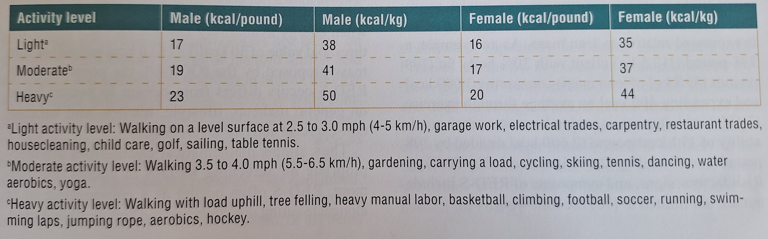
- 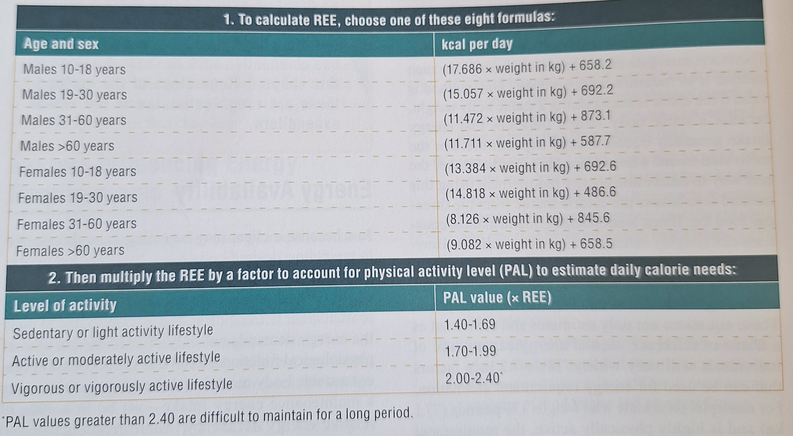
- The term energy availability refers to whether or not sufficient energy is available to meet the energy demands not only of exercise but also of physiological function. Specifically, a client may present a stable body mass - and therefore is consuming a maintenance energy intake - yet be in a state of relative energy deficiency, where reproductive and metabolic function are downregulated to maintain energy balance.
- As a natural physiological response to an energy deficit, adaptive thermogenesis (the downregulation of multiple components of energy expenditure, often called metabolic adaptation in fitness circles) can occur depending on the amount of weight lost and the magnitude of, and time spent in, an energy deficit.
- This adaptive response to an energy deficit is normal and can result in a cessation of weight loss, but in some cases - especially if weight loss is achieved with low energy availability - the reduction in energy expenditure can include downregulation of metabolic, hormonal, and other physiological functions.
- Risk factors, signs, and symptoms include:
  - Eating disorders and disordered eating
  - Extreme weight loss methods (e.g., crash diets. dehydration, vomiting, laxative use)
  - Very low resting heart rate or blood pressure
  - Loss of 10% of body mass or more in a single month
  - Changes in menstrual cycle regularity, or loss of menstrual cycle not associated with menopause.
  - Low markers for iron status
  - Low bone mineral density
  - BMI of 17.5 or lower
- Only health care professionals should attempt to diagnose or treat this condition.
- Nutrients:
- Protein
  - When determining how much protein a client needs, the personal trainer must consider a number of factors, including energy intake, activity level, the type of exercise performed, the body composition of the client, and in some cases, the source of protein.
  - Protein intake recommendations by health and government organizations are based on providing an adequate intake to prevent amino acid deficiency and subsequent declines in health; they are not intended to improve fitness, health, or body composition.
  - The U.S. Recommended Dietary Allowance (RDA) for protein for healthy, sedentary adults is 0.8 g/kg of body weight for both men and women.
  - If the goal is to enhance adaptations to resistance training -either strength or muscle mass gain- evidence indicates 1.6 g/kg per day will optimize outcomes for most individuals.
  - An upper-end recommendation of 2.2 g/kg per day may be appropriate for individuals with the specific goal of maximizing strength or muscle mass.
  - The personal trainer should be aware that exces- sively high protein intakes (e.g., greater than 4 g/kg body weight per day) are not indicated for clients with impaired renal function, those with low calcium intake. or those who are restricting fluid intake.
  - If excess total calories are consumed, even on a high-protein diet, fat storage can occur.
- Carbohydrate
  - A high-carbohydrate diet (up to 60%-70% of total calories) is commonly recommended for physically active individuals.
  - However, a variety of diets, with various carbohy- drate, protein, and fat mixtures, have been shown to be equally effective in supporting training and performance.
  - Which diet is appropriate depends on a client's goals, training regimen, personal preference and fitness level.
  - Individualizing carbohydrate intake based on the training program, individual genetics, and how the client has historically responded is imperative.
  - If a client is an aerobic endurance athlete he or she should replenish glycogen levels by consuming approximately 7 to 10 g/kg body weight per day.
  - Intake of approximately half of that recommended for aerobic endurance exercise appears adequate to support training and performance of strength, sprint, and skill exercise: thus an intake of 5 to 6 g/kg body weight per day is reasonable.
  - This amount may not be possible while consuming appropriate amounts of protein and fat. In such cases, clients should simply consume their remaining calories from carbohydrate after establishing an appropriate intake of dietary protein and fat (25).
  - Roughly 50 to 100 g of carbohydrate (the equivalent of three to five pieces of bread) per day prevents ketosis (high levels of ketones in the bloodstream) which results from the incomplete breakdown of fatty acids.
  - There is some evidence that a ketogenic diet may be suboptimal for the purposes of muscle gain.
  - Carbohydrate restriction is not necessary for fat loss. Restricting commonly consumed food sources such as bread can reduce dietary adherence.
- Fat
  - The human body has a low requirement for dietary fat.
  - It is estimated that individuals should consume at least 3% of energy from omega-6 (linoleic) fatty acids and 0.5% to 1% from omega-3 (alpha linolenic acid) fatty acids to prevent true deficiency
  - Diets with less than 15% fat may decrease testosterone production and thus negatively affect metabolism and muscle development.
  - Very-low-fat diets may impair the absorption of fat soluble vitamins.
  - The recommendation for the general public from most health organizations is that fat should contribute 30% or less of the total calories consumed. It is recommended that 20% of the total calories (or two-thirds of the total fat intake) come from monounsaturated or polyunsaturated sources, that less than 10% come from saturated fats (one-third of total fat intake), and that minimal manufactured trans fats from partially hydrogenated oils be consumed.
- Vitamins
- Minerals
  - Dietary Reference Intakes (DRIs), which are used in the United States and Canada, are recommendations of the Food and Nutrition Board for the intake of vitamins and minerals to be used for planning and assessing diets for healthy people.
  - The DRIs are split into four categories:
- Recommended Dietary Allowance (RDA)
- Adequate Intake
- Estimated Average Requirement
- Tolerable Upper Intake Level
  - It is important to remember that the recommendations for nutrient intakes represent the state of the science at the time, and as such, continue to evolve.
  - Historically, focus has been on inadequate nutrient intake. However, both inadequate intakes and exces- sive intakes are problematic.
  - 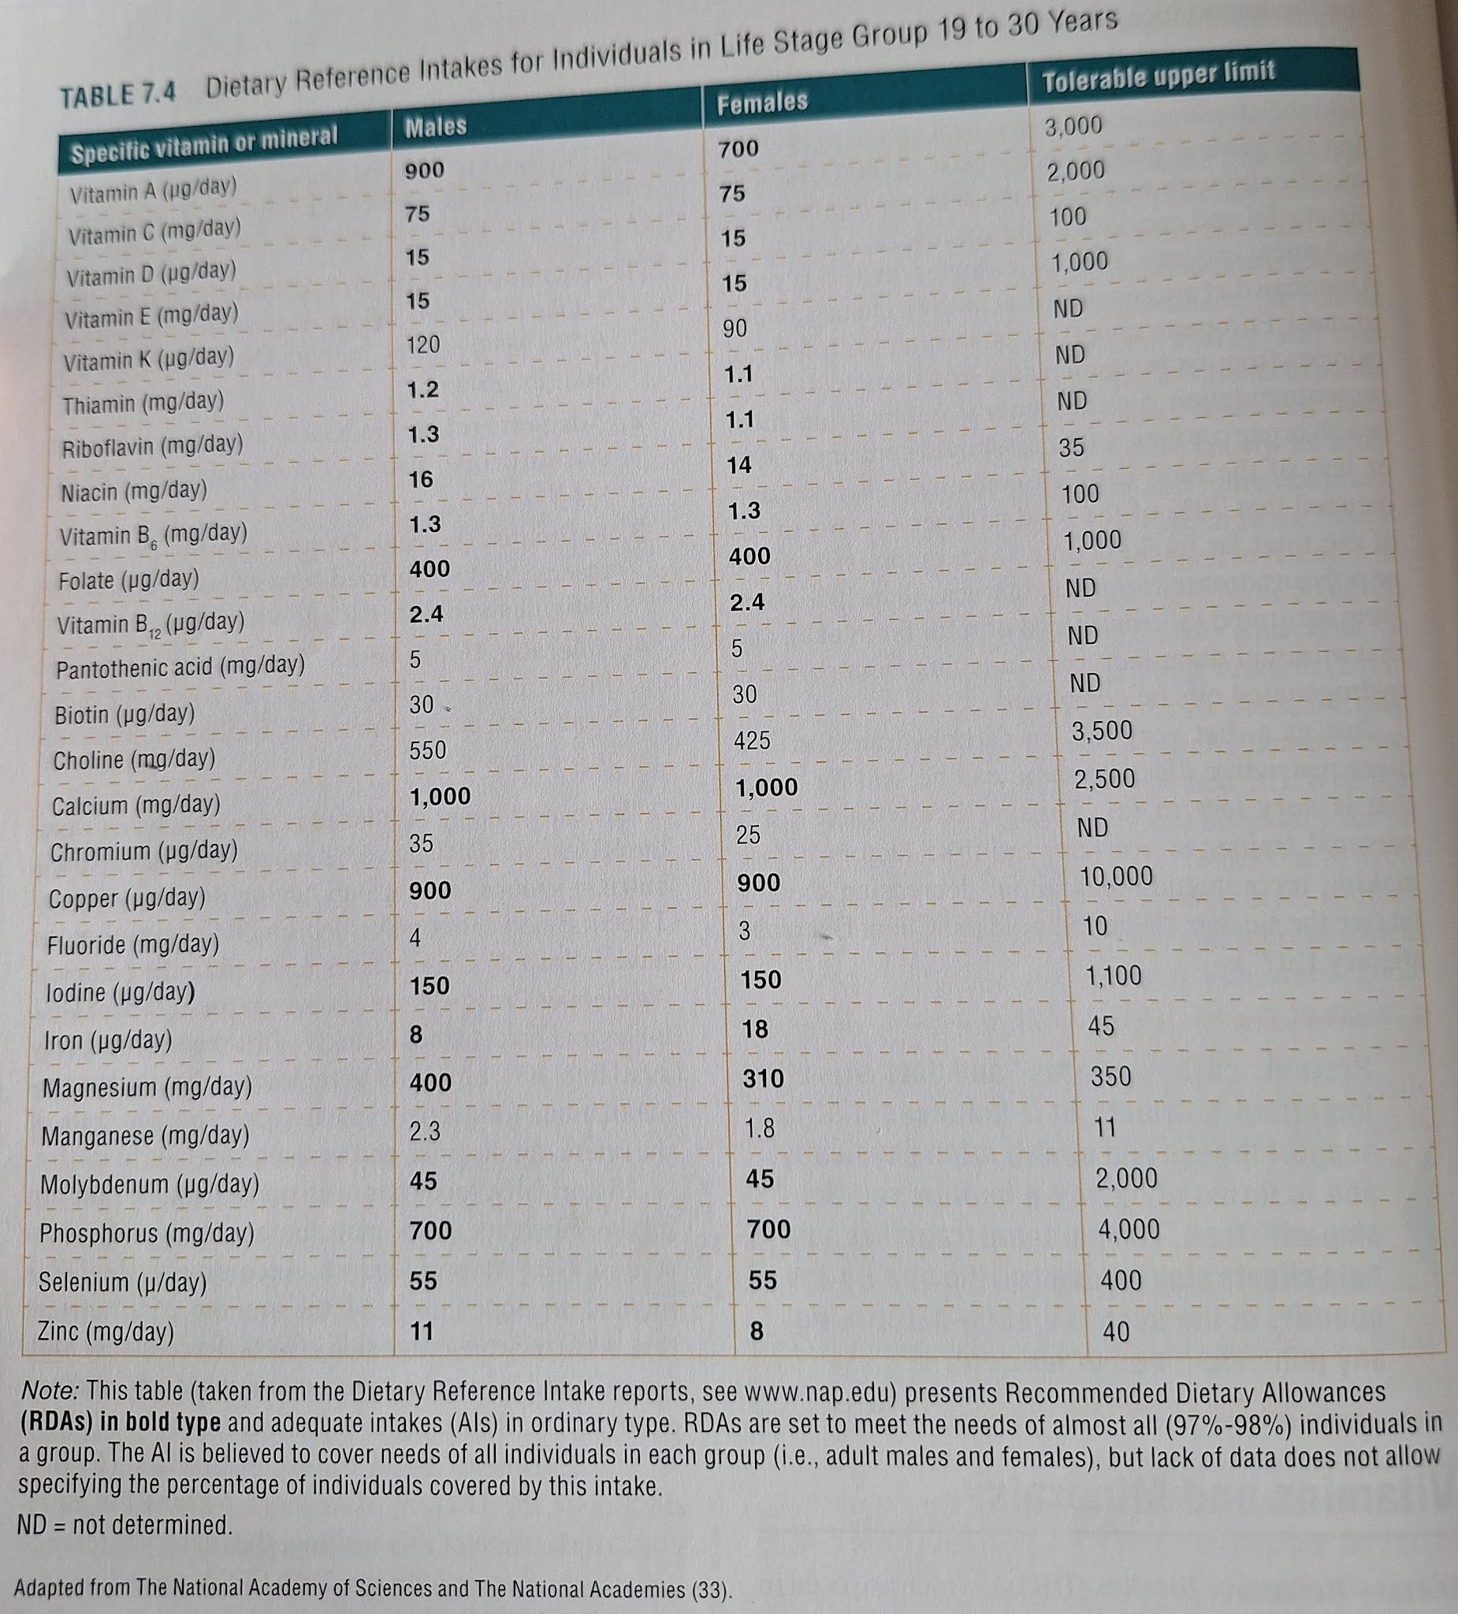
- Water
  - The reality is that water requirements change based on a variety of factors including environ- ment. sweating, body surface area, calorie intake, body size. and lean muscle tissue, leading to tremendous inter- and intraindividual variation.
  - Instead of looking at prescriptive amounts to be consumed each day, it is important for personal trainers to assess each client's situation and attempt to individualize recommendations.
  - Thirst is triggered at about 1% dehydration. Thus, encouraging fluid intake based on thirst works quite well to maintain fluid balance for healthy adult individuals in temperature-controlled environments who are sedentary and who have plenty of fluid read- ilv available.
  - The average fluid intake needed to offset fluid losses in sedentary adults may range from 1.5 to 2.7 quarts (1.4-2.6 L) per day.
  - Approximately 5 to 7 ml of fluid per kilogram body weight should be consumed at least 4 hours prior to exercise. Additional fluid should be consumed 2 hours prior to exercise, approximately 3 o 5 ml/kg body weight if urine is dark and scant.
  - Paradoxically, during exercise, humans do not adequately replace sweat losses when fluids are consumed at will.
  - Slight dehydration is common in almost all physical endeavors, and therefore rehydration is necessary.
  - Clients should drink 20 to 24 ounces (about 600 to 700 ml) of fluids for every pound lost (62). Sodium-rich foods or a sport drink should be used to stimulate thirst, replace ost electrolytes, and enhance rehydration.
  - Clients who have a goal of weight loss may misper- ceive acute weight loss during a workout as loss of fat and therefore see it as positive. It is important for personal trainers to clarify with clients that the acute weight loss during a workout is water, not fat, and must be replaced by hydrating.
  - When significant sweating has occurred, consump- tion of sodium chloride (salt) in the form of beverages or food minimizes urine output and hastens recovery of water and electrolyte balance. In practical terms, this means that consuming a wide variety of beverages and foods after training is important In fact, most fluid consumption occurs during and around mealtimes.
  - The goal of fluid replacement during exercise is to move the fluid from the mouth. through the gut, and into circulation rapidly and to provide a volume that matches sweat losses.
- Protein, carbohydrates, and fats are all important nutrients in a balanced diet to support fitness and health, both physically and in terms of having a healthy relation- ship with food. The personal trainer should help clients stay focused on the quality and quantity of the overall dietary pattern, not any individual food or nutrient.
- In general, there are three reasons for individuals to reduce dietary fat
- Need to increase carbohydrate intake to support training.
- Need to reduce total caloric intake to achieve weight loss.
- Need to decrease elevated blood cholesterol.
- There are two reasons clients may attempt to gain weight: to improve physical appearance or enhance athletic performance.
- For weight gain in the form of muscle mass, a combination of diet and progressive resistance training is essential. However, genetic predisposition, body type, and compliance determine the client's progress.
- Muscle tissue is approximately 75% water, 20% protein. and 5% fatty acids, minerals, metabolites, and glycogen.
- An intake of 350 to 500 kcal above nonresistance training energy requirements for maintenance may be needed to support a 1-pound (0.5 kg) weekly gain in lean tissue.
- To accommodate frequent eating, meal replacement drinks can come in handy, especially when a person is not hungry.
- The two primary nutrition principles for weight gain are to increase calorie intake and to ensure sufficient protein intake (or maintain an adequate level if already at 1.6 g/kg body weight per day or higher).
- People who have weight loss as a goal, specifically fat loss. can be split into two general groups: those who are normal weight but want to lose body fat for aesthetic reasons and those who are overweight or obese.
- The following are general principles to be considered when a client embarks on a weight loss regimen:
  - The ability to achieve and maintain minimal body fat is to some extent genetic.
  - Whether clients can gain muscle and lose body fat simultaneously depends on their training status, training program, and nutrition intake. (Could be hard to both for trained people)
  - An average loss of 1 to 2 pounds (0.5-0.9 kg) per week represents a daily caloric deficit of approxi- mately 500 to 1,000 kcal. which can be achieved through a combination of dietary restriction and exercise.
  - The diet should be composed of food low in energy density. Energy density refers to the calories per weight or volume of food.
  - The diet should be nutritionally balanced and should provide a variety of foods.
  - The diet should contain at least 1.6 g/kg body weight per day of protein, and possibly more (as high as 2.2 g/kg).
- The guiding principle for weight loss is to help clients achieve a negative energv balance. Manv clients think the issue is more complex than that, so the personal trainer should keep them focused on this principle, or more importantly, help them adopt habits that result in a negative energy balance.
- In general, foods with low energy density contain a high proportion of water and fiber. These are foods that people can eat in large portions without consuming excess calories.
- The truth is, any dietary regimen will lead to weight loss if and only if the person achieves a negative calorie balance.
- Personal trainers can help clients spot fad diets by checking for signs like the following:
  - The diet excludes one or more groups of foods.
  - It overemphasizes one particular food or type of food.
  - It is very low in calories.
  - The advocates discourage physical activity or indicate that it is not necessary.
  - The diet promises quick weight loss.
- One independent company, ConsumerLab.com, tests supplements for quality and purity and provides the results on its website.
- Although vitamin and mineral supplements are perceived to be without risk. excess intake of vitamins and minerals is not beneficial and, depending on the circumstance, potentially harmful.
- A common finding is that the individual's supple- mentation choices do not match the inadequacies of the diet, causing excess intakes of some nutrients without correcting the low intake of others. Helping a client adjust food and supplement choices to optimize the vitamin and mineral intake is a useful function of diet analysis.
- It is outside the scope of practice for a personal trainer to recommend supplements. Rather, it is the duty of the personal trainer to aid clients as consumers, ensuring they are informed of the safety and scientific legitimacy of products and know how to assess whether a supplement company follows best practices.
- Further, any time a client decides to use a dietary supplement, he or she should be guided to consult a registered dietitian.
- Nutritional status is influenced by intake over a relatively long period. Short-term dietary inadequacies or excesses will typically have a minimal impact on long-term status.
- The body can obtain the nutrients it needs through countless combinations of foods consumed over time. There is no "right way to eat" or "best diet" that applies to everyone.
- Closely tracking intake is not appropriate for all clients, however. Growing evidence demonstrates a potential link between the use of macronutrient, calorie, and weight tracking apps and websites with both attitudinal and behavioral eating disorder symptoms as well as increased psychological stress.
- It would be wise for most clients to closely track their intake only temporarily to gain an awareness of their food consumption and nutritional status.
- After this learning phase, the emphasis should be on nontracking. habit-based strategies focused on internal cues (hunger and satiety), with detailed tracking used only if progress is not made.
- Some of the most beneficial core concepts:
  - Be client centered, not coach centered. A client- centered coach respects their clients' values, priorities, and goals by putting their clients' agenda first.
  - Focus on solutions rather than on problems. Instead of focusing on the things clients are doing "wrong' or poorly (i.e., their problems), the personal trainer should focus on the things clients are already doing well and encourage them to do more of these positive habits.
  - Add before taking away. The personal trainer can have clients add more minimally processed. nutrient-rich whole foods that they like or are willing to trv before having them remove energy- dense, highly processed foods.
- Helping clients build skills and develop healthy eating habits requires a systematic process that is repetitive and cyclical to continually help clients progress toward their goals. The following five-step process can be employed to enhance success:
  - Step 1: Assess and gather data about goals, current intake, anthropometrics, and health status.
  - Step 2: Collaboratively create a solution-focused action plan and outline possible next steps.
  - Step 3: Collaboratively choose some next steps and have the client implement them. Prioritize the next steps from Step 2 and choose the next few the client will tackle.
  - Step 4: Observe and monitor outcomes of those steps.
  - Step 5: Assess and gather data about behaviors and outcomes (then repeat Steps 2 through 5).

Chapter 8 - Exercise Psychology, Goal Setting, and Motivation
- Understanding and implementing fundamental motivational principles can improve participation and program adherence as well as the intensity of effort during training sessions.
- In addition to the desirable physiological consequences of physical activity, there is ample scientific evidence that participation in physical activity has significant mental health benefits.
- Benefits:
  - Stress Reduction
    - Regular physical exercise relieves both state and trait anxiety-related symptoms; state anxiety refers to short-term stress-related processes while trait anxiety refers to long-term processes.
    - These effects are typically observed for aerobic forms of exercise across a wide range of intensities, although low-intensity and higher-volume resistance training appears to be efficacious as well.
    - [Explains possible reasons]
    - Overall, the change in psychological state from exercise is referred to as the feel-better phenomenon and may result from a complex interaction of social and psychobiological factors that come together to change the overall psychological state of the exercise partıcıpant.
  - Anti-Depressive Effects
    - Research evidence clearly and consistently reveals that physical exercise yields statistically significant and moderate effect sizes both for men and women who are clinically depressed and for those experiencing less severe forms of depression.
    - Exercise would seem to be a desirable alternative to psychiatric intervention or psychotherapy, given its relative cost-effectiveness and lack of unwanted side effects.
    - Physical exercise appears to be as effective as medication in men and women experiencing clinical depression.
    - [Explains possible reasons
  - Cognitive Benefits
    - Cognition consists of memory, analytical thinking, planning, focus concentration, and decision making. People who are physically fit seem to function more effectively than less physically active people on tasks involving cognitive demands.
    - The outcomes are particularly impressive in men and women in older age groups.
- The motivation and energy to engage in activity and exercise are critical elements in the achievement of such benefits. Goal setting is a powerful strategy for increasing the level of participation in exercise programs.
- This technique can be defined as a strategic approach to behavioral change by which progressive standards of success (i.e., goals) are set in an attempt to increasingly approximate a desired standard of achievement.
- Goal setting is not a one-size-fits-all endeavor. Rather than simply extracting information from an assessment and imposing goals on the client, it is important to identify the client's true wants and needs.
- Feedback and reinforcement are critical to the success of a goal-setting program as each progressive goal is sought.
- Feedback, or knowledge of results, is inherent in the completion of or progress toward the short-term goal and leads to the cognitive evaluation of success or failure.
- Goals that are challenging but nearer to the present ability level of the client are superior to too-easy or very difficult goals to effecting behavior change.
- The purpose of a long-term goal is to provide a meaningful pursuit for the client.
- A short-term goal provides a strategy to achieve the long-term goal via attainable steps. Challenging short-term goals are an effective tool to elicit the effort and intensity from the client that will result in a meaningful physiological and psychological change.
- A challenging goal is one that has about a 50% chance of success.
- A well-constructed short-term goal represents a compromise between guaranteeing success, as in the case of a goal that is too easy and requiring too much effort. Short-term goals are meaningless if they are not reasonably difficult.
- Types of goals:
  - Process goals are goals that clients have a high degree of personal control over.
  - Outcome goals are ones the client has little control over.
  - Performance goals fall in between in relation to personal control.
- Overall, it seems appropriate to set a variety of goals or diversify the goal-setting strategy to balance the client's underlying reasons for exercise, while maintaining a reasonable probability of success and reinforcement.
- A successful goal-setting program should include a variety of goals just as financial success entails a diversified financial portfolio.
- Positive feedback from the attainment of such process and short-term performance goals can perpetuate the sense of desire and commitment to the long-term goal.
- The principle is that a variety of goals associated with varying levels of personal control may well sustain commitment and adherence to the physical training program
- A successful goal-setting program should include a diverse combination of short-term and long-term goals.
- Clients who gauge their performance improvement on the basis of previous ability level are said to be task-involved. On the other hand, ego-involved or other-referenced clients base their sense of improvement on comparison with the performance of one or more others.
- Promoting self-referenced goals and recognizing (i.e., praising) when a client's goals are achieved helps emphasize goals that are achievable by the client and fosters their task involvement. To be effective in goal setting, personal trainers want to include the type of goals that fit their clients’ goal orientations and perceived ability.
- Tips for Effective Goal Setting:
  - Determine the client's perceived needs and desires and agree on and plan the long-term goals.
  - Figure out the steps and the short-term goals that will lead to long-term achievement.
  - When starting out with a new client, clarify a preliminary goal based more on process than on performance.
  - Once the client begins accumulating small successes, additional goals, including more challenging performance goals may be added.
  - Both the personal trainer and client should recognize that absence of required knowledge can hinder the achievement of long-term goals.
  - As time progresses and the client proves to be committed to the sessions and the results, it is appropriate to set more aggressive process and performance goals.
  - Once measurable goals are clarified, attach a time frame to each goal.
  - Agree on a way to recognize whether the program is working.
  - After setting goals, always check to make certain the client believes they are attainable.
  - Examine the goals to make sure they are compatible with one another.
  - Goals should be prioritized.
- Attach a time frame to each goal and note if a goal is not achieved by the assigned date. Goals can and should be evaluated and adjusted at regular intervals.
- Practical Principles of Effective Goal Setting:
- Make goals specific, measurable, action oriented, realistic, time bound (SMART).
- Clearly identify time constraints.
- Set moderately difficult goals.
- Record goals and monitor progress.
- Diversify process, performance, and outcome goals.
- Set short-term goals to achieve long-term goals.
- Make sure goals are internalized (clients should participate or set their own).
- According to its basic definition, motivation is a psychological construct that arouses and directs behavior. A construct is simply an internal drive or neural process that cannot be directly observed but must be indirectly inferred from observation of outward behavior.
- Reinforcement is any act, object, or event that increases the likelihood of future operant behavior when the reinforcement follows the target behavior; and punishment is any act, object, or event that decreases the likelihood of future operant behavior when the punishment follows that behavior.
- Reinforcement increases the likelihood that a behavior will be repeated, and punishment decreases the likelihood that a behavior will be repeated.
- The terms positive reinforcement and negative reinforcement are often confused. Both terms refer to consequences that increase the probability of occurrence of a desired behavior or operant; but positive reinforcement “gives” something to the client in response to the behavior, while negative reinforcement “takes away” something.
- Personal trainers modify clients' behavior more successfully by using a reinforcing style of leadership by providing instructional feedback and reinforcement of the client's progress.
- An intrinsically motivated client truly loves to exercise, whereas an extrinsically motivated client typically exercises only to achieve an external reward.
- Although some people may be able to maintain their exercise behavior based solely on extrinsic reinforcement, the more clients move toward being intrinsically motivated, the more likely they are to continue their exercise behavior.
- In actuality, external rewards or recognition can reduce intrinsic motivation.
- [Explain stages of readiness: Precontemplation, Contemplation, Preparation, Action, Maintenance]
- Self-efficacy is a person's confidence in his or her own ability to perform specific actions leading to a successful behavioral outcome.
- Four types of influences affect or build self-efficacy:
- Performance accomplishments
- Modeling effects
- Verbal persuasion
- Physiological arousal or anxiety
- Practical Motivational Techniques:
- Have the client use an exercise log or journal to document baseline measurements and the details of each workout.
- Begin clients with exercise sessions that involve familiar activities.
- Whenever possible, offer choices.
- Provide feedback often. Look for small achievements.
- Model the appropriate behavior for a fitness lifestyle.
- Prepare the client for periods during which adherence may be disrupted.
- Use social support resources.
- Let the past go.
- Use a "do your best" outlook instead of a "be perfect" attitude.
- Agree on a motivational affirmation and have the client write it down.
- Methods to Motivate a Client:
  - Minimizing Procrastination
  - Identifying False Beliefs
  - Identifying and Modifying Self-Talk
  - Mental Conditioning
    - Mental Imagery
    - Relaxation and Deed Breathing
      - Deep breathing reduces muscular tension, and improves their relaxation.

Chapter 9 - Client Consultation and Health Appraisal
- Scope of practice: “Personal trainers are health fitness profession- als who use an individualized approach to assess, motivate, educate, and train clients regarding their health and fitness needs. They design safe and effective exercise programs and provide guidance to help clients achieve their personal goals. In addition, they respond appropriately in emergency situations. Recognizing their area of expertise, personal trainers refer clients to other health care professionals when appropriate”
- No recognized uniform process of administration appears to exist.
- During the initial interview, the personal trainer and client assess compatibility, develop goals, and establish a client-personal trainer agreement.
  - As the first step in determining personal trainer-client compatibility, the personal trainer provides a detailed description of the services available.
  - Developing goals that are specific, measurable, action oriented, realistic, and time sensitive (SMART) is a vital element of the training process.
  - Entering into an agreement under the elements of contract law requires a formal process that in most cases is legally driven. Components of a contract include written documentation describing the services, parties involved, expectations of those parties, timeline of delivery, cost structure, and a payment process (consult with an attorney).
  - They then must then enter an agreement to validate the safe use of the facility. This form is an agreement of facility permissions, indicating what the personal trainer and client are permitted to use while inside the facility.
- Steps of the client consultation and health appraisal
- Schedule interview appointment
- Conduct interview
- Implement and complete health appraisal forms
- Evaluate for coronary risk factors, diagnosed disease, and lifestyle
- Assess and interpret results
- Refer to an allied health professional when necessary
- Obtain medical clearance and program recommendations
- The first step in the preparticipation health appraisal screening process is to ask the client to complete relevant forms (PAR-Q+ and a health/medical questionnaire).
- Additional Screening:
  - Lifestyle questionnaires: they vary in their format, substance, and depth. However, they usually consist of questions to evaluate personal choices and patterns related to dietary intake, management of stress. level of physical activity, and other practices that may affect the person's health.
  - Informed consent form: gives clients information about the content and process of the program delivery system.
  - An assumption of risk or waiver is an agreement by a client before beginning participation, to give up, relinquish, or waive the participant's rights to legal remedy (damages) in the event of injury, even when such injury arises because of provider negligence.
- The personal trainer needs to develop a strategy to collect. organize, and store the vital information and materials obtained through the initial interview process.
- The personal trainer needs to follow HIPAA (Health Insurance Portability and Accountability Act) protocols with sensitive client material pertaining to personal and private health information.
- The scope of practice of the personal trainer involves the responsibility to interview potential clients to gather and assess pertinent information about their personal health, medical conditions, and lifestyle to meet their individual health and fitness objectives safely and effectively.
- Identifiable positive risk factors are associated with the potential to acquire CVD (Cardiovascular Disease):
  - Age: reaching the threshold of 45 years for men and 55 years for women.
  - Family History: myocardial infarction, coronary revascularization, or sudden death occurred before 55 years of age in their biological father or another male first-degree relative (sibling or child), or before 65 years of age in their biological mother or other female first-degree relatives.
  - Cigarette smoking: Persons who currently smoke cigarettes, and those who previously smoked but who have quit within the last six months, or those individuals exposed to environmental tobacco smoke.
  - Physical inactivity: not perform at least 150 minutes a week of moderate-intensity or 75 minutes of vigorous-intensity physical activity.
  - Body mass index/waist circumference: body mass index (BMI) equal to or greater than 30 kg body weight per height in meters squared or a waist girth >40 inches (102 cm) for mer and >35 inches (88 cm) for women.
  - Blood pressure: Systolic blood pressure >130 mmHg and/or diastolic >80 mmHg, based on an average of >2 readings obtained on >2 occasions.
  - Blood lipid levels: Individuals who have low-density lipoprotein cholesterol (LDL-C) >130 mg/dl (3.37 mmol/L) or non-high-density lipoprotein cholesterol (HDL-C) >160 (4.14 mmoL/L), or men with HDL-C of <40 mg/dL (1.04 mmol/L) or women with HDL-C <50 mg/dL (1.04 mmoL/L), or individuals who are on lipid-lowering medication.
  - Blood glucose levels: fasting plasma glucose levels of >100 mg/dl (5.5 mmol/L), plasma glucose values from an oral glucose tolerance test of >140 mg/d 7.77 mmol/L), or an HbA1C of >5.7%
- High-density lipoproteins appear to provide a protective mechanism against CVD by removing cholesterol from the body and preventing plaque from forming in the arteries.
- The personal trainer needs to use enhanced observation throughout the client consultation and health appraisal process to identify and assess signs and symptoms suggestive of cardiovascular and pulmonary disease that the client may exhibit.
- Sudden cardiac death related to exercise is caused by cardiac arrest that occurs instantaneously with an abrupt change in an individual's preexisting clinical state or within a few minutes of that change. Exercise does not typically provoke cardiovascular events in healthy individuals with normal cardiovascular systems.
- It is important for the personal trainer to include sudden cardiac death risk factors in the health/medical questionnaire to identify individuals who may be at risk for sudden cardiac death. It is also important to advance all clients according to individual readiness. Sudden cardiac death at all ages is more prevalent in those who perform activity that they are not accustomed to.
- Persons with type 1 diabetes are insulin dependent, meaning they require insulin injections to metabolize glucose. Persons with type 2 diabetes in most cases can produce insulin, but the tissue is insensitive to it, and consequently glycemic control is inadequate.
- Diabetes is known to be an independent contributing factor in the development of CVD, increasing the potential for developing CVD, peripheral vascular disease, and congestive heart failure.
- Issues related to orthopedic replacements, recent surgical procedures osteoporosis, and rheumatoid arthritis may require communication with a physician and in most cases medical clearance.
- It is important for the personal trainer to understand the classes of commonly used drugs and their effects.
- Lifestyle Evaluation
  - Dietary Intake and Eating Habits
    - There is a solid link between dietary intake and disease (saturated fat, alcohol, sodium, calories)
  - Exercise and Activity Pattern
  - Stress Management
    - Epidemiological studies provide evidence that stress is related to the risk for CVD.
- To meaningfully interpret the results obtained through the screening process, the personal trainer should use the PAR-Q+ results to identify people who have a greater potential for risk and may require referral and a clearance from a physician.
- [Describes American College of Sports Medicine Preparticipation Screening Algorithm]
- It is also reasonable to recommend that persons beginning a new program of activity or exercise consult with a physician before participation.
- [Describes PAR-Q+]
- Components that can be evaluated during a preparticipation examination include but are not limited to the following: body weight, body composition, pulse rate, blood pressure, heart sounds and breath sounds (auscultation), palpation of the major arteries, and the skin on the feet and legs of clients with diabetes mellitus.
- A physician may recommend an unsupervised, supervised, or medically supervised exercise program.
  - An unsupervised program is commonly recommended for people who are apparently healthy or presumably healthy with no apparent risks.
  - A supervised program may be recommended for people who have limitations or preexisting conditions that would restrict involvement but not limit participation.
  - A medically supervised program may be recommended for individuals who present a higher potential risk because of a predisposed condition, multiple risk factors, or an uncontrolled disease.
- [4 case studies]
- [The Attitudinal Assessment]
- [Personal Training Contract/Agreement]
- [2021 PAR-Q+]
- [Health/Medical Questionnaire]
- [Health Risk Analysis Form] - Cool, basically estimates life expectancy.
- [Physician's Referral Form]

Chapter 10 - Fitness Evaluation, Selection, and Administration
- There is no one-size-fits-all test or battery of assessments that will suit each client and circumstance.
- The purposes of assessment are to gather baseline data and to provide a basis for developing goals and effective exercise programs.
- The data collected provide:
  - a baseline for future comparisons of improvement or rate of progress
  - identification of current strengths and weaknesses
  - assistance in establishing appropriate intensities and volumes of exercise
  - assistance in clarification of short-intermediate- and long-term goals
  - identification of areas of potential injury or contraindications before program initiation
  - a record demonstrating prudent judgment and appropriate scope of practice in program design
- The assessment process may fall within the services typically provided to all clients, may constitute an additional revenue stream for the personal trainer, or may do both.
- The first step in individualizing the personal trainer's approach to each client is determining the specific tests to give to measure various parameters of health- and skill-related fitness.
- Every observation of a client provides important data that the personal trainer must consider in designing, implementing, and modifying that client's program.
- Reliability is a measure of repeatability or consistency of a test or an observation. A common method of determining reliability of a test is the test-retest method.
- Validity indicates that a test measures what it is supposed to measure.
- A valid test is one that measures what it purports to measure. A reliable test is one that can be repeated with accuracy by the same tester or another. A good assessment instrument is both valid and reliable.
- When a specific test is selected to assess a client, the same test should be used for any further testing of the given fitness component.
- All tests have a standard error of measurement which is the difference between a person's observed score and that person's true score.
- Factors That Affect Reliability and Validity:
  - Client Factors
    - Health status and functional capacity: The health status and functional capacity of a client dictate which assessments are appropriate.
    - Age: Chronological age and maturity may influence testing performance.
    - Sex: Sex-specific biological factors may influence performance in a variety of activities or assessments such as the chin-up, push-up, and bench press to assess muscular endurance of the upper extremities.
    - Pretraining status: Caution should be emphasized in assessment of untrained. deconditioned individuals even when they express a desire to achieve high performance levels.
  - Personal Trainer Factors
    - The level of experience and training of the personal trainer has an impact on the selection of assessments. To maintain objectivity and reduce intrarater error, testing protocols that require adept technical skills need to match the abilities of the personal trainer.
    - Personal trainers who are unfamiliar with administration of an assessment should not select it but should continue their professional development by taking time to practice administration of the assessment for use with future clients.
  - Equipment Factors:
    - Any mechanism or device used to measure work, performance, or physiological response requires calibration, or the adjusting of the device to ensure precision, in order to accurately measure the specific trait being assessed.
  - Environmental Factors:
    - Temperature and Humidity: The environment poses challenges related to physiological responses that may have an impact on test administration and performance.
    - Altitude: Altitude can also impair aerobic endurance performance (if higher than 580 m)
    - Air Pollution: Pollution can have a negative effect on performance and health by decreasing the ability of the blood to transport oxygen, by increasing the resistance in the airways, and by altering the perception of effort for a given task.
    - Test Setting: To minimize external distractions and the potential anxiety related to the assessment process, the testing area should be quiet and private. The personal trainer should project a positive, relaxed, confident demeanor; and the process should be clearly explained and not rushed.
- The integrity of the assessment process depends on the validitv and reliabilitv of the assessments selected and proper administration bv a trained fitness professional. Personal trainers should take care to enhance reliabilitv bv consistentlv attending to controllable factors related to the client, personal trainer, equipment and environment.
- Selecting valid, reliable, and safe assessments that will provide meaningful results requires an understanding of the health status, risk factors for cardiovascular dis- ease, and goals of the client: a high level of experience of the personal trainer: the availability of relevant equipment; and knowledge of the specific test characteristics associated with the assessment.
- [2 case studies]
- For Laboratory tests, it is helpful to have equipment such as the following:
  - Bicycle ergometer or treadmill
  - Equipment for measuring body composition (e.g. skinfold calipers)
  - Equipment for measuring flexibility e.g. goniom- eter or sit-and-reach box
  - Equipment for measuring the force of muscular contraction (e.g., dynamometer)
  - Perceived exertion chart
  - Stopwatch
  - Metronome
  - Sphygmomanometer
  - Stethoscope
  - Tape measure
  - Bodyweight scale
  - First aid kit
  - Automated external defibrillator (AED)
- Field tests are practical assessments that are inexpensive, are easy to administer, require less equipment, are less time consuming, can be performed at various venues. and may be more efficient for evaluating large groups. Examples of field tests include walk/run tests, agility tests, and 1RM tests.
- An appointment for the assessment should be sched- uled in advance in order for the client to adequately prepare mentally and physically for the event.
- The client should receive pretest instructions in preparation for the assessment. These include
  - Adequate rest (e.g., 6 to 8 hours the night before and no vigorous exercise 24 hours preceding the test)
  - Moderate food intake (e.g., a light meal or snack 2 to 4 hours before the test)
  - Adequate hydration
  - Abstinence from chemicals that accelerate heart rate (with the exception of prescribed medications)
  - Proper attire (e.g., loose-fitting clothing; sturdy athletic shoes)
  - Specific testing procedures and expectations before, during, and after the test; and
  - Conditions for terminating a test.
- It is important for clients to be told that they may terminate a test for any reason at any time.
- General indications for stopping an exercise test:
  - Onset of angina or angina-like symptoms
  - Drop in systolic BP of >10 mmHg with an increase in workload, or if SBP decreases below the value obtained in the same position prior to testing
  - Excessive rise in BP: systolic pressure >250 mmHg and/or diastolic pressure >115 mmHg
  - Shortness of breath, wheezing, leg cramps, or claudication
  - Signs of poor perfusion (e.g., light-headedness, confusion, ataxia, pallor, cyanosis, cold or clammy skin, or nausea)
  - Failure of HR to rise with increased exercise intensity
  - Noticeable change in heart rhythm by palpation, auscultation, or ECG
  - Client requests to stop
  - Physical or verbal manifestations of severe fatigue
  - Failure of the testing equipment
- An organized method to collect. record. and store data is critical in reducing the incidence of error and is instrumental to the evaluation and interpretation of testing results.
- The personal trainer must determine the proper order of testing.
- Many clients do not require a battery of tests as inclusive as the lists that follow.
- General Fitness
- Resting tests (e.g., resting heart rate, blood pressure, height, weight, body composition)
- Nonfatiguing tests (e.g., flexibility, balance)
- Muscular strength tests (e.g., 10RM bench press)
- Local muscular endurance tests (e.g., YMCA bench press test, partial curl-up test)
- Submaximal aerobic capacity tests (e.g., step test. Rockport walking test, Åstrand-Rhyming cycle ergometer test, 1.5-mile [2.4 km] run, 12-minute run/walk)
- Athletic Performance
- Resting tests (e.g., resting heart rate, blood pres- sure, height, weight, body composition)
- Nonfatiguing tests (e.g., flexibility, vertical jump)
- Agility tests (e.g., T-test)
- Maximum power and strength tests (e.g., 3RM power clean, 1RM bench press)
- Sprint tests (e.g., 40-yard [36.6 m] sprint)
- Local muscular endurance tests (e.g., 2-minute sit-up test, 1-minute push-up test)
- Anaerobic capacity tests (e.g., 300-yard [274.3 m shuttle run, Wingate anaerobic test)
- Maximal or submaximal aerobic capacity tests e.g., maximum treadmill test, 1.5-mile [2.4 km run, YMCA cycle ergometer test
- If possible, it is more appropriate to schedule assessments to measure maximum anaerobic (e.g.. repeat-sprint or shuttle tests, exhaustive sprint tests such as the Wingate anaerobic test) and aerobic capacity (e.g.. aerobic tests to failure) on a separate day.
- The personal trainer should also provide a demonstration of appropriate test performance and should give the client an opportunity to practice and ask questions about the protocol.
- It is the responsibility of the personal trainer to ensure that testing protocols are followed safely and efficiently.
- The personal trainer should institute an adequate warm-up and cooldown procedure when warranted and implement spotting practices when required by the testing protocol.
- Administration of the assessments should follow a standardized procedure including mentally and physically preparing the client, verifying the accuracy of the equipment, applying the specific test protocol, ensuring safety throughout the process, and performing record-keeping responsibilities.
- Norm-referenced standards are used to compare the performance of an individual against the performance of others in a like category.
- Many clients are content to know their raw (performance) score and whether they get stronger, faster, or more flexible after training. Clients who are very unfit or who have had negative experiences with fitness testing in the past may have no interest in knowing how poorly they performed compared with others.
- Criterion-referenced standards are set against a combination of normative data and the best judgment of the experts in a given field to identify a specific level of achievement.
- The problem is that exact cutoffs for health for each component of fitness for all segments of the adult population have not been identified and universally accepted.
- This limitation can be an issue for a deconditioned client who scores at or near the bottom of a column on a norm-referenced table; the results may be demoralizing if the client thinks, mistakenly, that he or she must score at or near the top to be healthy.
- The client should receive an illustrated summary of the test results, along with an explanation of personal strengths and areas identified that may have room for improvement. It is important to note that testing data are neither good nor bad-they are baseline data to provide a foundation for positive change.
- Once the assessments are complete and the personal trainer has reviewed the results with the client, the program is designed and implemented based on the client's goals.
- A time frame for accomplishing goals is set, and posttests are scheduled. The date scheduled for a posttest may be eight or more weeks from program initiation.
- The personal trainer should keep in mind that reassessments performed too frequently may disclose a learning effect by the client rather than true physiological changes.
- For most clients, regardless of whether norm- or criterion-referenced standards are used, it is more appropriate to have them compare their own performances over time than against the skills or fitness levels of others.
- [Test Preparation and Implementation Checklist]
- [Individual Assessment Recording Form]

Chapter 11 - Fitness Evaluation Protocols and Norms
- Vital Signs:
  - Heart Rate
    - On average, the HR for females is 7 to 10 beats/min greater than that for males.
    - Those slower than 60 beats/min are classified as bradycardia and those higher than 100 beats/min as tachycardia.
    - As procedure used to assess HR, any one or a combination of the following devices may be necessary
      - Stopwatch
      - Stethoscope
      - Heart rate monitor
    - Palpation is probably the most common and certainly the most cost-effective method for assessing both resting and exercise HR ([Note] it then explains how to do it)
    - Any one of the following anatomical landmarks can be used to palpate the pulse:
      - Brachial artery
      - Radial artery
      - Carotid artery
      - Temporal artery
    - If the HR is counted for less than a full minute, use a multiplier to convert the measurement to beats per minute.
    - Auscultation requires the use of a stethoscope.
    - Factors Affecting HR Assessment incr. HR if not specified):
      - Smoking and tobacco products
      - Caffeine
      - Environmental temperature extremes
      - Altitude
      - Stress
      - Food digestion
      - Body position (decr. HR when supine, incr. HR from supine to seated position or standing position)
      - Time of day (decr. HR first thing in the morning, incr. or same during afternoon or evening hours)
      - Medications (Depends)
  - Blood Pressure
    - Blood pressure (BP) can be defined as the forces of blood acting against vessel walls. The sounds that are emitted as a result of these vibratory forces are called Korotkoff sounds.
    - Although there are various invasive and noninvasive techniques for determining BP, sphygmomanometry is the most commonly used field technique and as such gives personal trainers a convenient tool for evaluating their clients' BP.
    - Repeated BP measurements are important for detecting hypertension.
    - Equipment
      - Mercury or aneroid sphygmomanometer
      - Air bladder-containing cuff
      - Stethoscope
    - [Note] it then explains the procedure.
    - Factors Affecting BP Assessment
      - Smoking and tobacco products (incr.)
      - Caffeine (depends)
      - Stress (incr.)
      - Body position (decr. when supine, incr. when standing)
      - Time of day (decr. first thing in the morning, incr. or same during afternoon or evening hours)
      - Medications (depends)
    - Common errors for blood pressure measurement
- The stethoscope is put on backward resulting in the earpieces not pointing toward the personal trainer's ear canals.
- The measurement dial is not at the personal trainer's eye level
- The bell of the stethoscope is under the blood pressure cuff.
- The blood pressure cuff is placed too close to the bend in the client's elbow (termed the antecubital space or fossa).
- The blood pressure cuff is either too large or small for the client's arm.
- The blood pressure cuff is not inflated enough to correctly capture the first Korotkoff sound.
- The air is released out of the blood pressure cuff either too quickly or too slowly.
    - After a minimum of 2 minutes' rest, measure BP again using the same technique. If the two consecutive measurements of either the SBP or the DBP differ by more than 5 mmHg, take a third BP measurement and record the average of the three SBP and the average of the three DBP measurements as the final scores.
    - Tips for blood pressure measurement
      - The client should be seated comfortably with the back supported and the legs not crossed.
      - The upper arm should be bare and have no restrictive clothing.
      - The client's arm should be completely relaxed and supported at approximately heart level
      - The bladder of the cuff should cover at least 80% of the client's upper arm.
      - The cuff should be deflated at 2 or 3 mm/s, with the first and last audible sounds taken as the SBP and DBP, respectively
      - Both the client and tester should remain quiet during testing.
- Training Load
  - Training load reflects the relative balance between the various stressors imposed on the body via exercise, termed external training load, and the body's physiological response to exercise, termed internal training load (perceived exertion or wellness rating).
  - External Training Load:
    - From a resistance exercise perspective, this can be accomplished by tracking the total number of repetitions (i.e., sets x repetitions) or volume load (sets x repetitions x load [in Ib or kg]) for a given training session.
    - From an endurance- or team-sport perspective, this can be accomplished by tracking the total distance covered or the number and intensity of shorter-distance runs during a training session.
  - Internal Training Load:
    - The most straightforward method of evaluating internal training load involves determining the client's rating of perceived exertion or perceptual well-being.
    - The process of determining perceptual well-being relies on the consistent recording of an)y number of factors that may reflect how the client is responding to the training program.
    - An example containing individual ratings for sleep, muscle soreness, general stress, and fatigue is provided.
  - 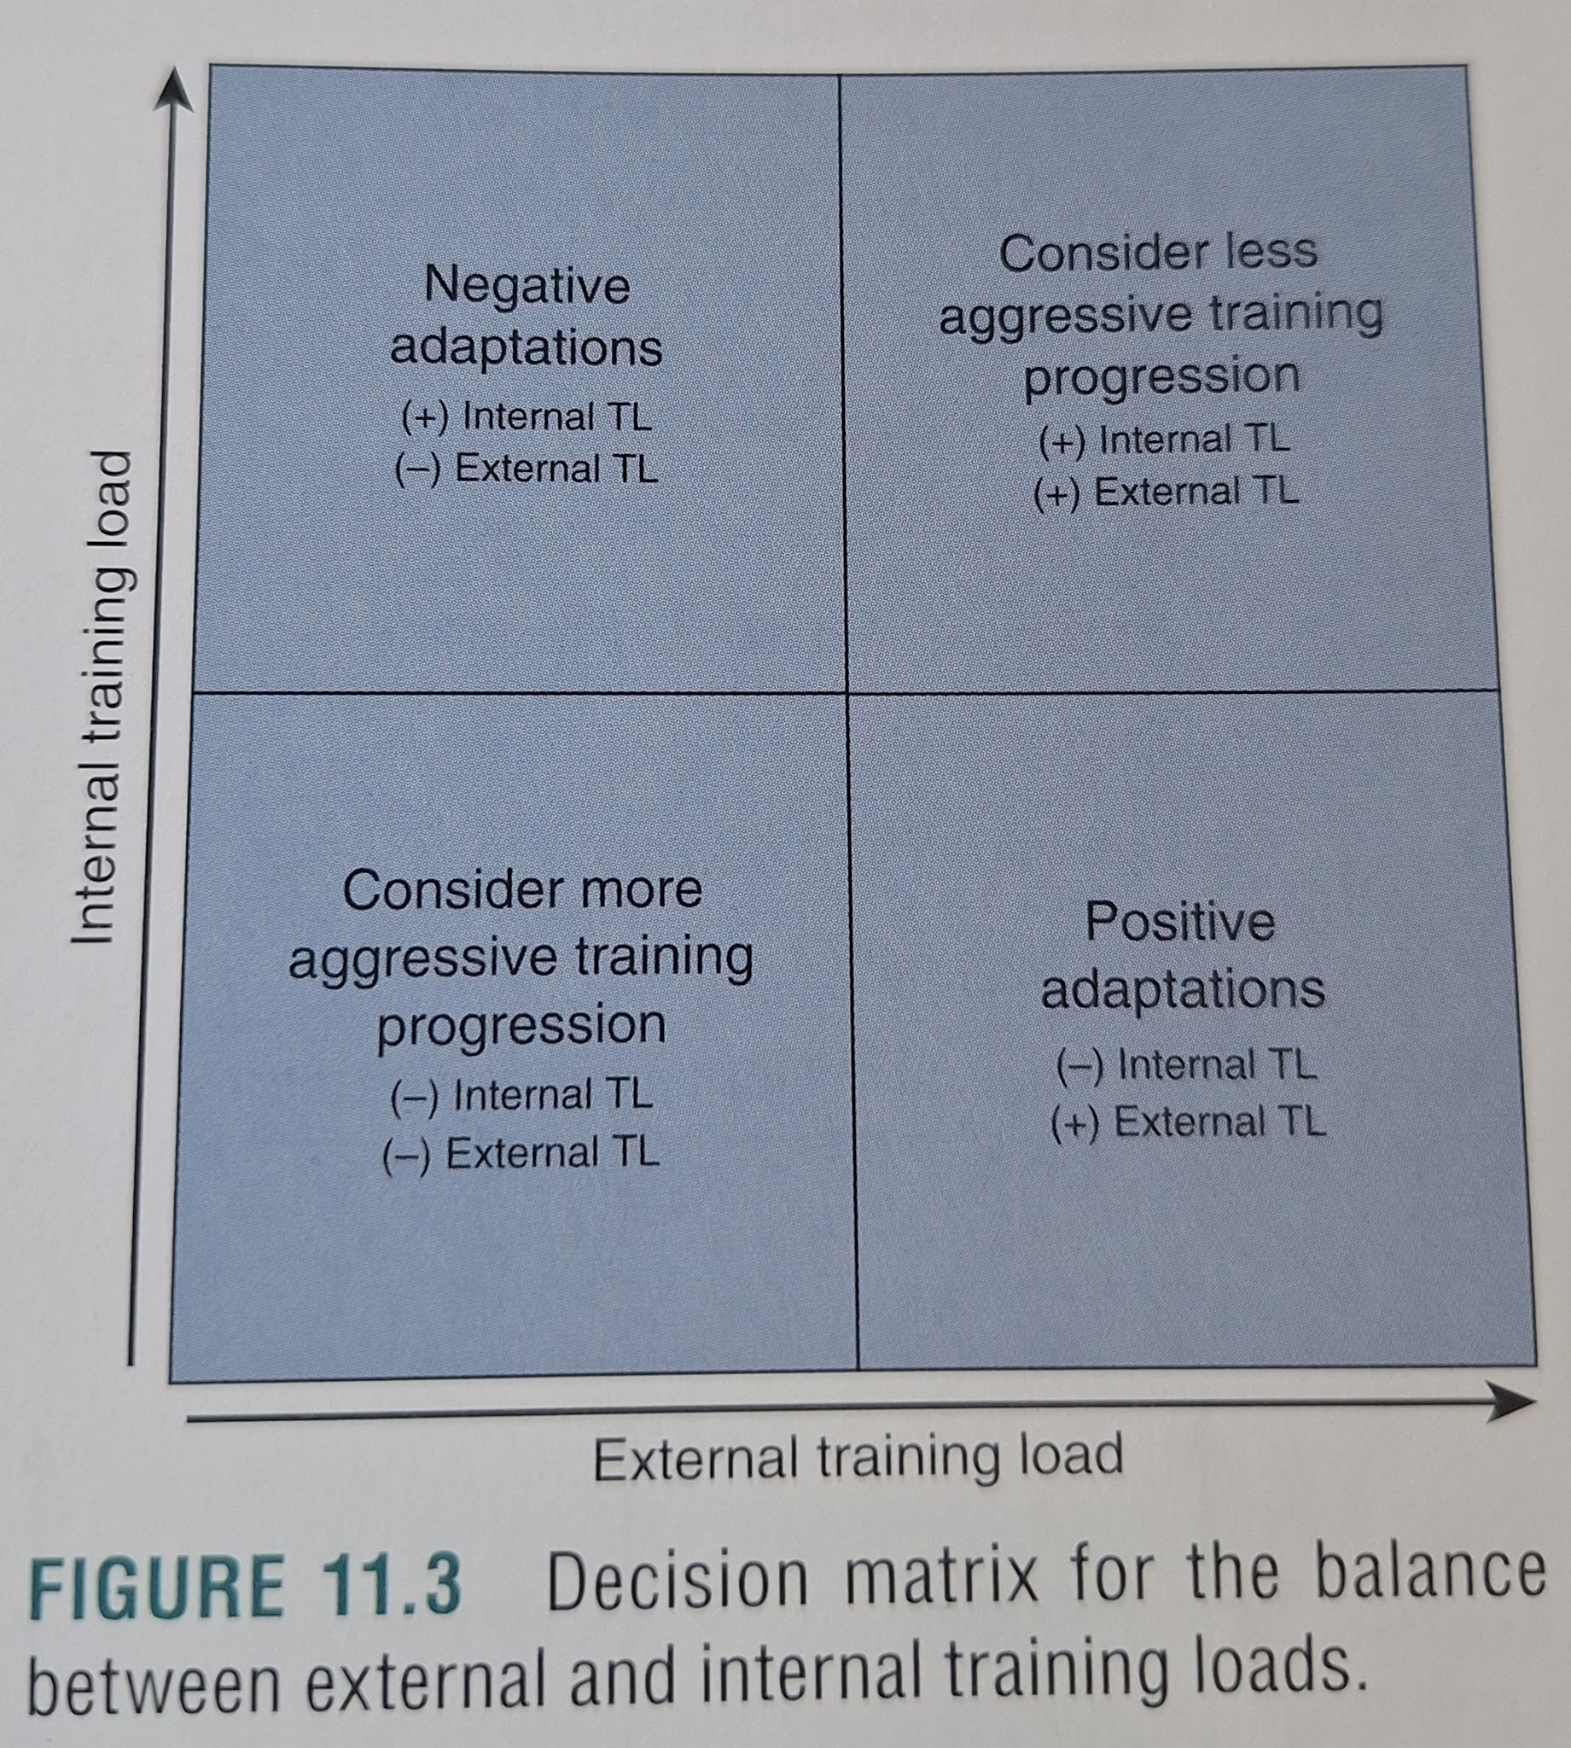
- Body Composition
  - Anthropometry:
    - Anthropometry, which is the science of measurement applied to the human body, generally includes measurements of height, weight, and selected body girths.
    - Clients should be weighed while wearing minimal dry clothing (e.g. gym shorts and T-shirt no shoes).
    - For comparison measurements at a later date, they should dress similarly and be weighed at the same time of day.
    - The most reliable body mass (weight) measurements are made in the morning upon rising, after elimination and before ingestion of food or fluids.
    - The most reliable girth measurements are usually obtained with the aid of a flexible measuring tape equipped with a spring-loaded attachment at the end that, when pulled out to a specified mark, exerts a fixed amount of tension on the tape (e.g., a Gulick tape).
    - Girth measurements can be made at the beginning of a training or incentive period for comparison with subsequent measurements.
  - Body Mass Index
    - Personal trainers often use the body mass index (BMI) to examine body mass related to stature.
    - BMI (kg/m2) = Body weight (kg) / Height^2 (m2)
    - Note that BMI does not take into account the relative composition of an individual.
    - BMI alone should not be used to monitor weight loss or program Success.
  - Height
    - Height is a basic anthropometric measurement for which stature is a more accurate term.
    - Equipment
      - Depending on the procedure used to assess a client's stature, one of the following devices is necessary
        - Standard platform scale with stadiometer
        - Flat, ridged, right-angled device (to simultaneously slide against a wall and rest on top of client's crown)
    - [Note] it then explains the procedure
    - Factors Affecting BMI Assessment:
      - Previous meals (incr. after meal consumption)
      - Time of day (decr. first thing in the morning, incr. during afternoon or evening hours)
      - Hydration status (decr. when dehydrated; body mass will decr. postexercise because of sweat loss)
  - Weight
    - The term weight is defined as the mass of an object under the normal acceleration due to gravitv: ther a more accurate term to characterize body weight is body mass.
    - Equipment
      - Calibrated and certified scale
    - [Note] it then explains the procedure
  - Skinfolds
    - Skinfolds (SF) indirectly measure the thickness of subcutaneous fat tissue. Sum of SF measurements are highly correlated with body density (Db) measurements from underwater weighing when using population-specific SF equations.
    - Most equations use multiple SF sites to predict Db, which can then be converted to percent body fat (%BF) using the appropriate prediction equation ([Note] Show equations as well)
    - The accuracy of SF measurements can be affected by the skil level of the technician, the type of caliper used, client factors, and the prediction equation used to estimate %BF.
    - To improve intrarater reliability, it is recommended that personal trainers practice SF measurements on 50 to 100 clients in order to develop a high degree of skill and proficiency.
    - Given that the type of caliper used is a potential source of error, using the same caliper when monitoring changes in SFs is recommended, as well as periodically checking the accuracy of the caliper and calibrating it as needed.
    - Equipment
      - Skinfold caliper
      - Nonelastic (i.e., plastic or metal) tape measure
      - Pen or other marking device
    - General Considerations for Skinfold Testing
      - Take all skinfold measurements on the right side of the body.
      - Take the skinfold measurements before exercise and when the client's skin is dry and free of lotion.
      - Carefully identify, measure, and mark the skinfold site.
      - Grasp the skinfold firmly between the thumb and fingers. The placement of the thumb and fingers should be at least 1 cm (0.4 inches) away from the site to be measured.
      - Lift the fold by placing the thumb and index finger approximately 8 cm (~3 inches) apart on a line that is perpendicular to the long axis of the skinfold.
      - Keep the fold elevated while taking the measurement
      - Place the jaws of the caliper perpendicular to the fold, 1 cm (0.4 inches) away from the thumb and index finger, and release the jaw pressure slowly
      - Record the skinfold measurement after 1 to 2 seconds (but within 4 seconds) after the jaw pressure has been released.
      - Take a minimum of two measurements at each site. lf the values vary by more than 2 mm or 10% take an additional measurement.
    - [Note] it then explains the procedure
  - BIA Techniques
    - Bioelectrical impedance analysis (BIA) is a noninvasive, relatively inexpensive method for measuring body composition.
    - BIA works via measurement of the amount of impedance or resistance to a small, painless electrical current passed through the body between two electrodes, which are often placed on the wrist and ankle.
    - Total body water (TBW) is estimated from the impedance measurement because electrolytes in the body's water are excellent conductors of electrical current. Impedance measures are higher in individuals with large amounts of body fat because of the low water content in adipose tissue. Conversely, individuals with larger amounts of fat free mass (FFM) have less resistance to the current flowing through their bodies because the water content of FFM is relatively large (-73% water).
    - Some authors have suggested that BIA methods for determining body composition are roughly as accurate as skinfold techniques.
    - Inexpensive lower body (foot-to-foot) and upper body (hand-to-hand) BIA devices have become available for home and commercial use. They provide estimates of %BF and FFM using proprietary equations developed by the manufacturers.
    - For healthy clients with normal fluid balance, these analyzers provide reasonably accurate estimates of FFM, reporting small prediction errors.
    - BIA measurements can be easily and significantly affected by factors such as hydration status, racial characteristics, and the prediction equation used. Eating, drinking, dehydration, exercise, and men- strual cycle phase can affect total body resistance and the estimate of FFM.
    - There is a tendency for BIA to overestimate body fat in lean individuals and underestimate body fat in obese individuals.
    - BIA pretesting guidelines:
      - Refrain from eating or drinking within four hours of the test
      - No exercise within 12 hours of the test
      - No alcohol consumption within 48 hours of the test
      - No diuretic medications within seven days of the test
      - Do not test female clients who perceive they are retaining water during their menstrual cycle
      - Ask clients to void their bladder within 30 minutes of the test.
  - Waist-to-Hip Girth Ratio
    - Although not truly a measure of body composition per se, measurement of the waist-to-hip ratio is a valuable tool for assessing relative fat distribution and risk of disease. Individuals with a larger accumulation of fat in the trunk, particularly abdominal region, are at increased risk for a variety of cardiovascular and metabolic diseases.
    - Equipment
      - Nonelastic (i.e., plastic or metal) tape measure
    - [Note] it then explains the procedure
- Cardiovascular Endurance
  - The personal trainer can use submaximal cardiovascular endurance tests to attain a reasonably accurate estimation of a client's v02max. Submaximal exercise tests are used most often because of high equip- mentexpenses, the personnel needed, and the increased risks associated with maximal tests.
  - The concept behind a submaximal test is to monitor HR, BP, or rating of perceived exertion (RPE)-or some combination of these-during exercise until a predetermined percentage of the client's predicted maximal HR is achieved, at which point the test is terminated.
  - Maximal tests are not safe or necessary for many clients and sometimes cannot be conducted without physician supervision.
  - Assumptions and Solutions for Submaximal Exercise Tests
    - Assumption 1: Heart rate measurements must be steady state.
      - Solution: personal trainers should record HR values at the end of a constant work- rate stage or after 2 or 3 minutes of exercise at a constant work rate (6). Steady-state HR is defined as two consecutive HR measurements that are within five beats/min of each other
    - Assumption 2: True maximal HR for a given age must be the same for all clients.
      - Solution: the typical equation to calculate age-predicted maximal HR can introduce an unknown error into the model for submaximal estimation of v02max.
    - Assumption 3: The relationship between HR and work rate must be strong, positive, and linear
      - Solution: The positive relationship between HR and workload is most linear between 50% and 90% of maximal HR.
    - Assumption 4: Mechanical efficiency (VO2 at a given work rate) is the same for all clients
      - Solution: Personal trainers should choose a test that is specific to the client's existing cardiovascular exercise mode(s), daily activities, or both.
  - General procedure for cycle ergometer testing
    - [Note] it then explains the procedure
  - YMCA Cycle Ergometer Test
    - The YMCA cycle ergometer test is a submaximal, multistage exercise test for cardiovascular endurance. This popular test is designed to progress clients to 85% of their predicted maximal HR using 3-minute stages of increasing work rate.
    - Equipment
      - Mechanically or electrically braked cycle ergometer.
      - Metronome (if the cycle ergometer does not have an rpm gauge)
      - Stopwatch
      - Heart rate and BP measurement equipment (see "Heart Rate" and "Blood Pressure" sections earlier in this chapter
      - Rating of perceived exertion scale
    - [Note] it then explains the procedure
    - [Note] it then explains how to estimate VO2max from the test. There's a formula for that.
    - VO2max (ml*kg-1*min-1) = [(10.8 x W)-BW]+7
    - Where:
      - W = the predicted maximal work rate (in watts)
      - BW= body weight (kg)
    - Work rate (kg * m * min-1) = Resistance (kg) x Distance (m) x Cadence (rom
    - Work rate (W) = Work rate (kg * m * min-1) ÷ 6.12
    - Example here:
    - 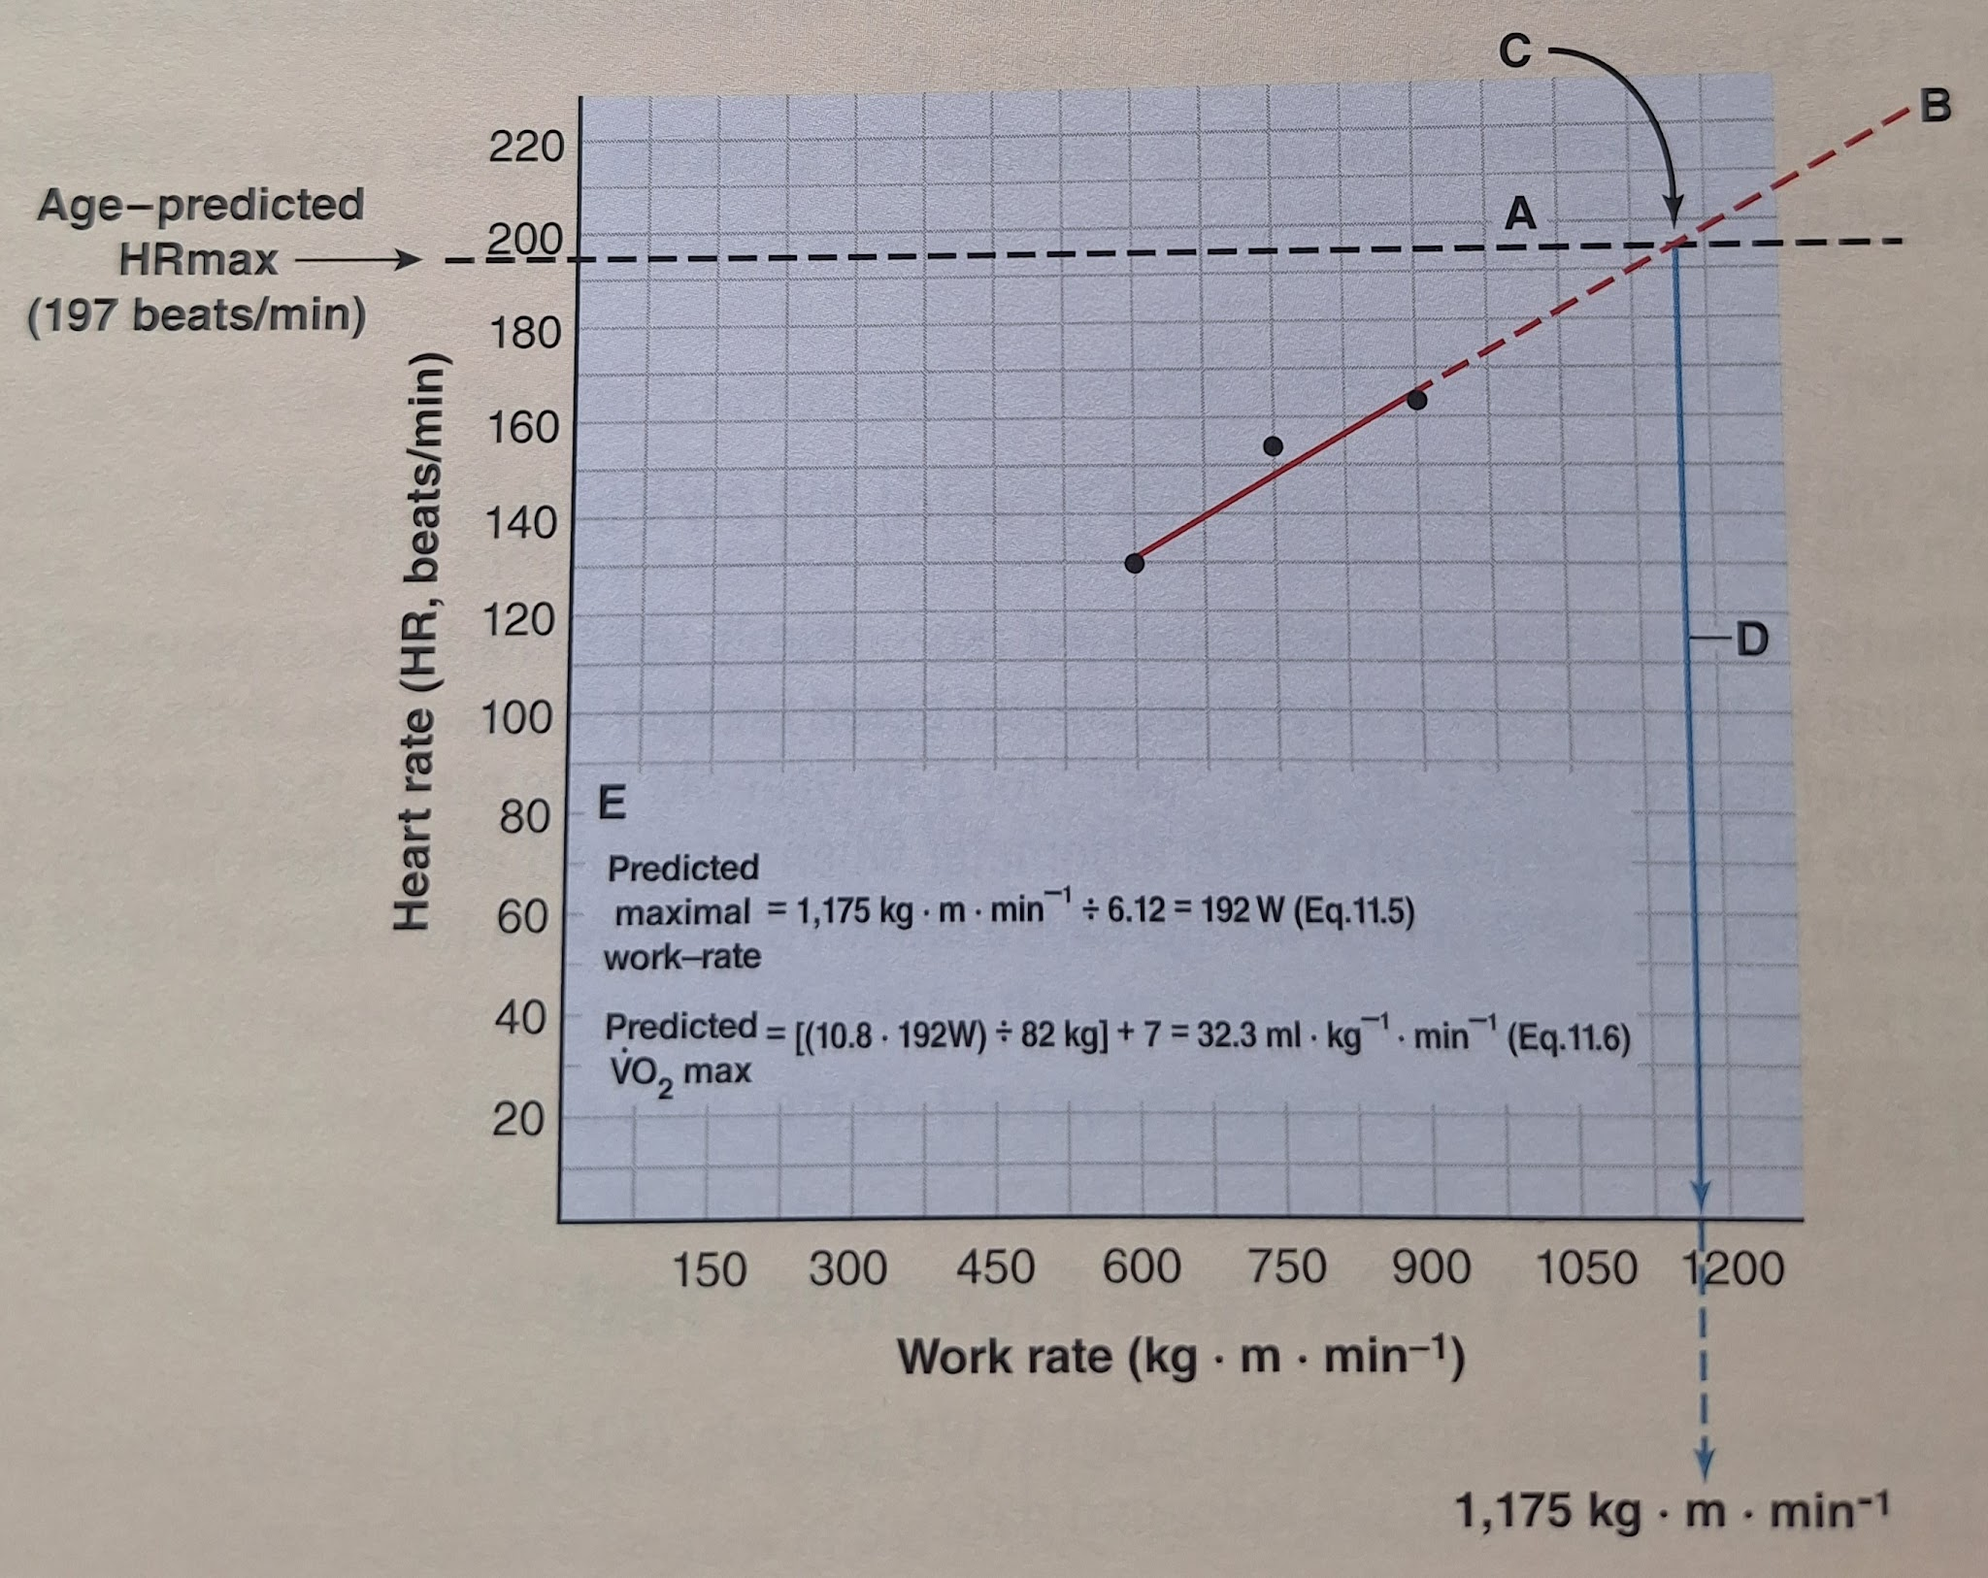
  - Åstrand-Rhyming Cycle Ergometer Test
    - Åstrand-Rhyming cycle ergometer test is a single-stage test. Total duration of the test is 6 minutes
    - Equipment
      - Mechanically or electrically braked cycle ergometer
      - Metronome (if the cycle ergometer does not have an rpm gauge)
      - Stopwatch
    - [Note] it then explains the procedure
    - VO2max (ml * kg-1 * min-1) = V02max in L/min x 1,000 + BW
    - Where
      - BW = body weight in kilograms (kg)
    - [Note] HR -> Table -> Age correction -> Conversion with formula above
  - YMCA Step Test
    - The YMCA step test is a basic, inexpensive cardiovascular endurance test that can be easily administered individually or to large groups.
    - This test classifies fitness levels based on the postexercise HR response but does not provide an estimation of VO, max.
    - The objective of the YMCA step test is to have the client step up and down to a set cadence for 3 minutes and to measure the HR recovery response immediately after the test.
    - Equipment
      - 12-inch or 30 cm step bench or box
      - Metronome set at 96 beats/min
      - Stopwatch
    - [Note] it then explains the procedure
  - 12-minute Run/Walk Test
    - The 12-minute run/walk test is a field test designed to measure the distance traveled over 12 minutes of running, walking, or a combination of both. After distance is recorded as the test score, it is used in a regression equation to estimate VO2max
      - VO2max (ml * kg-1 * min-1) = (0.022351 x D) - 11,3
      - Where
        - D= distance complete in meters
    - Equipment
      - 400-meter (437-yard) track or flat course with measured distances so that the number of laps completed can be easily counted and multiplied by the course distance
      - Visible place markers
      - Stopwatch
    - [Note] it then explains the procedure
  - 1.5-Mile Run
    - The 1.5-mile run is a field test designed to measure the time it takes for a client to run 1.5 miles (2.4 km). Once the time is recorded as the test score, it is used in a regression equation to estimate VO2max.
      - VO2max (ml * kg-1 * min-1) = 88.02 - (0.1656 x BW) - (2.76 x time + (3.716 x sex)
      - Where:
        - BW = Body Weight in Kg
        - time in minutes
        - Sex = 1 for males, 0 for females
    - Equipment
      - 400-meter (437-yard) track or flat course with the 1.5-mile (2.4 km) distance measured
      - Stopwatch
    - [Note] it then explains the procedure
  - Rockport Walking Test
    - The Rockport walking test has been developed to estimate VO2max for men and women ages 18 to 69 years.
    - Because this test requires only walking at a fast pace, it is useful for testing older or sed- entary clients.
    - Equipment
      - Stopwatch
      - Measured 1-mile (1.6 km) walking course that is flat and uninterrupted (preferably an outdoor track)
      - VO2max (ml * kg-1 * min-1) = 132.853 - (0.0769 x BW) - (0.3877 x age) +(6.315 x sex) - (3,2649 x time) - (0.1565 x HR)
      - Where
        - BW = body weight in pounds
        - age= age in years
        - time = 1-mile walk time to completion
        - HR = heart rate in beats per minute
        - sex = 1 for males and 0 for females
    - [Note] it then explains the procedure
  - 1-Mile Run
    - The 1-mile run has been developed to estimate cardiovascular endurance for children ages 6 to 17 years.
    - Equipment
      - Stopwatch
      - A flat and uninterrupted 1-mile (1.6 km) course.
    - [Note] it then explains the procedure
  - Non-Exercise-Based Estimation of VO2max
    - Non-exercise-based equations have been developed to estimate a client's V02max from various demographic and descriptive variables.
    - These equations have been used to provide reasonable estimates of VO2max for both trained and untrained men and women.
    - Equipment
      - Standard platform scale with anthropometer arm or flat, ridged, right-angled device (to simultane- ously slide against a wall and rest on top of client's crown)
      - Calibrated and certified scale.
      - Rating of perceived exertion scale
    - [Note] it then explains the procedure
- Speed and Agility
  - Speed and change- of-direction tests are popular in athletic evaluation settings.
  - Maximal speed and the time required to achieve maximal speed are typical outcomes of sprint tests
  - Agility tests provide an indication of planned or unplanned change-of-direction speed using a variety of movement patterns.
  - Straight-Line Sprint Tests
    - Straight-line sprint tests assess maximal speed and acceleration.
    - A 40-yard (36.6 m) sprint test with a static start from a standing two-point stance will be described.
    - Equipment
      - Measuring tape
      - Cones, markers. adhesive tape, or field paint
      - Timing device
    - [Note] it then explains the procedure
  - 300-Yard Shuttle
    - The 300-yard (274.3 m) shuttle provides an indicator of anaerobic capacity through a combination of sustained sprinting and change-of-direction abilities
    - Equipment
      - Measurina tape
      - Cones, markers, adhesive tape, or field paint
      - Timing device
    - [Note] it then explains the procedure
  - T-Test
    - The T-test reflects speed and agility using planned change-of-direction ability and varied movement patterns (sprinting, side-shuffling, and backpedaling)
    - Equipment
      - Measuring tape
      - Cones or markers
      - Timing device
  - Pro Agility (20-Yard Shuttle Run, or 5-10-5 Test)
    - The pro agility test reflects planned change-of-direction ability and speed during several short sprints separated by quick turning movements
    - Equipment
      - Measuring tape
      - Cones, markers, or field paint
      - Timing device
    - [Note] it then explains the procedure
- Muscular Strength
  - Strength may be tested as 1-repetition maximum (1RM or multiple-repetition maximum and expressed either as absolute strength or as relative strength.
  - Absolute strength is simply the raw strength score a person achieves, while relative strength is usually expressed relative to body weight.
  - Many personal trainers prefer not to have their clients perform 1RM testing because of safety or technique concerns.
  - Fortunately, it is possible to estimate a client's 1RM from a submaximal resistance. This involves having the client perform multiple-repetition maximum testing.
  - Multiple-Repetition Maximum Bench Press
    - A multiple-repetition maximum (e.g., 5RM) bench press test may be used to measure upper body strength. Because free weights are used, this test requires skill on the part of the client being tested
    - Equipment
      - Adjustable barbell and weight plates that allow resistance increments of 5 to 90 pounds (2.5-40 kg
    - [Note] I'll note procedure here because it's more relevant to me.
    - Procedure (Provide a spotter and closely observe technique.)
- Instruct the client to warm up with a light resistance that easily allows 8 to 10 repetitions
- Provide a 1-minute rest period
- Estimate an additional warm-up load that the client will use to complete 6 to 8 repetitions by adding as follows:
- Upper body exercise: 5-to 10-pound increase (~2.5-5 kg)
- Lower body exercise: 15-to 20-pound increase (~7.5-10 kg)
- Provide a 2- to 4-minute rest period
- Make a load increase (same as before)
- Instruct the client to attempt a 5RM
- If the client was successful, provide a 2- to 4-minute rest period and go back to step 5. If the client failed, provide a 2- to 4-minute rest period and decrease the load as follows (half of the increase)
- Continue increasing or decreasing the load until the client can complete 5 repetitions with proper exercise technique. Ideally, the client's multiple-repetition maximum value will be measured within 3 to 5 testing sets.
- Record the 5RM value as the maximum weight lifted (i.e., the client's absolute strength) for the last successful attempt.
      - Once these steps are completed , either record the multiple-repetition maximum strength values or use the conversion nomograms.
      - You can also divide the estimated 1RM value by the client's body weight to determine relative strength for comparison against values provided in table 11.
  - Multiple-Repetition Maximum Leg Press
    - The multiple-repetition maximum leg press may be used to measure lower body strength
    - Equipment
      - Universal leg press machine.
        - Normative data will apply only if a Universal leg press machine is used.
    - [Note] it then explains the procedure, which is very similar to Bench Press one
- Muscular Power
  - Muscular power is the abilitv to produce force (i.e. muscular strength) within a short time. In athletic settings, power is often referred to as explosiveness and may be a better indicator of performance than strength or speed alone.
  - When assessing muscular power, fitness professionals must consider the joints being used, the planes of movement, and the skill and technique required to successfully, and safely, complete the selected tests.
  - Vertical Jump Test
    - The vertical jump test evaluates muscular power in the vertical plane, primarily using the lower body with assistance from the trunk and upper body (i.e., momentum)
    - Equipment
      - Wall with high ceiling
      - Chalk
      - Measuring tape
      - Alternative equipment: vertical jump measurement device (e.., Vertec, switch mat
    - [Note] it then explains the procedure
  - Standing Long Jump Test
    - The standing long jump (or broad jump) test evaluates muscular power in the horizontal plane, primarily using the lower body with assistance from the trunk and upper body.
    - Equipment
      - Adhesive tape or field paint
      - Measuring tape
    - [Note] it then explains the procedure.
  - Medicine Ball Chest Pass Test
    - The medicine ball chest pass test evaluates muscular power using an upper body pushing movement.
    - Equipment
      - Incline bench at a 45-degree angle
      - Medicine ball (6 kg [13.2 lb] for females, 9 kg [19.8 lb] for males)
      - Measuring tape
    - [Note] it then explains the procedure.
- Muscular Endurance
  - Muscular endurance is the ability of a muscle or muscle group to exert submaximal force for extended periods.
  - YMCA Bench Press Test
    - The YMCA bench press test is used to measure upper body muscular endurance This is a test of absolute muscular endurance; that is, the resistance is the same for all members of a given sex.
    - Equipment
      - Adjustable barbell and weight plates
      - Metronome
    - [Note] it then explains the procedure.
  - Sit-up Test
    - The sit-up test is a two-minute assessment designed to measure localized endurance of the abdominal muscles.
    - Equipment
      - Mat
    - [Note] it then explains the procedure.
  - Prone Double Straight-Leg Raise Test
    - The prone double straight-leg raise is useful for examining low back muscular endurance and predicting potential low back pain.
    - Equipment
      - A mat or massage table
    - [Note] it then explains the procedure.
- Flexibility
  - Flexibility refers to the range of motion (ROM) around a joint (e.g., shoulder) or a series of joints (e.g. vertebral column).
  - There is no single test that can measure whole-body flexibility. Separate tests need to be administered for each area of interest.
  - Traditionally, personal trainers have focused on tests that measure the flexibility of joints believed to be associated with risk of developing low back pain.
  - Sit-and-Reach
    - The sit-and-reach test is often used to measure hip and low back flexibility.
    - A lack of hip and low back flexibility, along with poor muscular strength and endurance of the abdominal muscles, is believed to be predictive of low back pain.
    - Equipment
      - Yardstick or sit-and-reach box
      - Adhesive tape
      - Measuring tape
    - [Note] it then explains the procedure.
  - Back Scratch Test
    - The back scratch test is used as an indication of upper body flexibility and shoulder range of motion which contribute to the ability to complete activities of daily living and a variety of overhead movements related to exercise
    - Equipment
      - Measuring tape or ruler
    - [Note] it then explains the procedure.
- Postural Alignment and Movement Assessment
  - Postural alignment and movement assessments provide the opportunity for fitness professionals to evaluate potential inherent physical limitations or functional imbalances that may impede the ability of clients to engage in the training process.
  - Plumb Line Assessment
    - The plumb line assessment is often used as a reference of alignment for the body when examining static posture. It is made up of a hanging line (string, rope, or cord) attached to a small weight and suspended in front of a postural grid (or body diagram). The plumb line provides a vertical line of reference by which anatomical landmarks can be assessed
    - Equipment
      - A string suspended overhead with a small weight at the bottom (plumb line)
      - A body diagram to show plumb line alignment (optional)
    - [Note] it then explains the procedure.
    - [Note] Description of Common Faults Identified Using Plumb Line Assessment page 250.
  - Closed Kinetic Chain Upper Extremity Stability (CKCUES) Test
    - The closed kinetic chain upper extremity stability (CKCUES) test is an assessment tool for upper limit function and stability. It can also be used for assessing risk of injury to the shoulder and upper extremities.
    - The test requires the client to assume a push-up position and, while alternating hands, tap a piece of tape on the floor next to the opposite hand as many times as possible within 15 seconds.
    - Equipment
      - Measuring tape
      - Adhesive tape
      - Stopwatch
    - [Note] it then explains the procedure.
  - Single-Leg Squat and Forward Step-Down Tests
    - The single-leg squat and forward step-down movements are used to assess movement quality in the lower limb.
    - They require strength, proprioception, neuromuscular control, and adequate range of motion at the hip, knee, and ankle joints.
    - During these tests, the quality of the movement is observed and assessed using a qualitative assessment tool developed specifically for lower limb tasks
    - [Note] it then explains the procedure.
    - 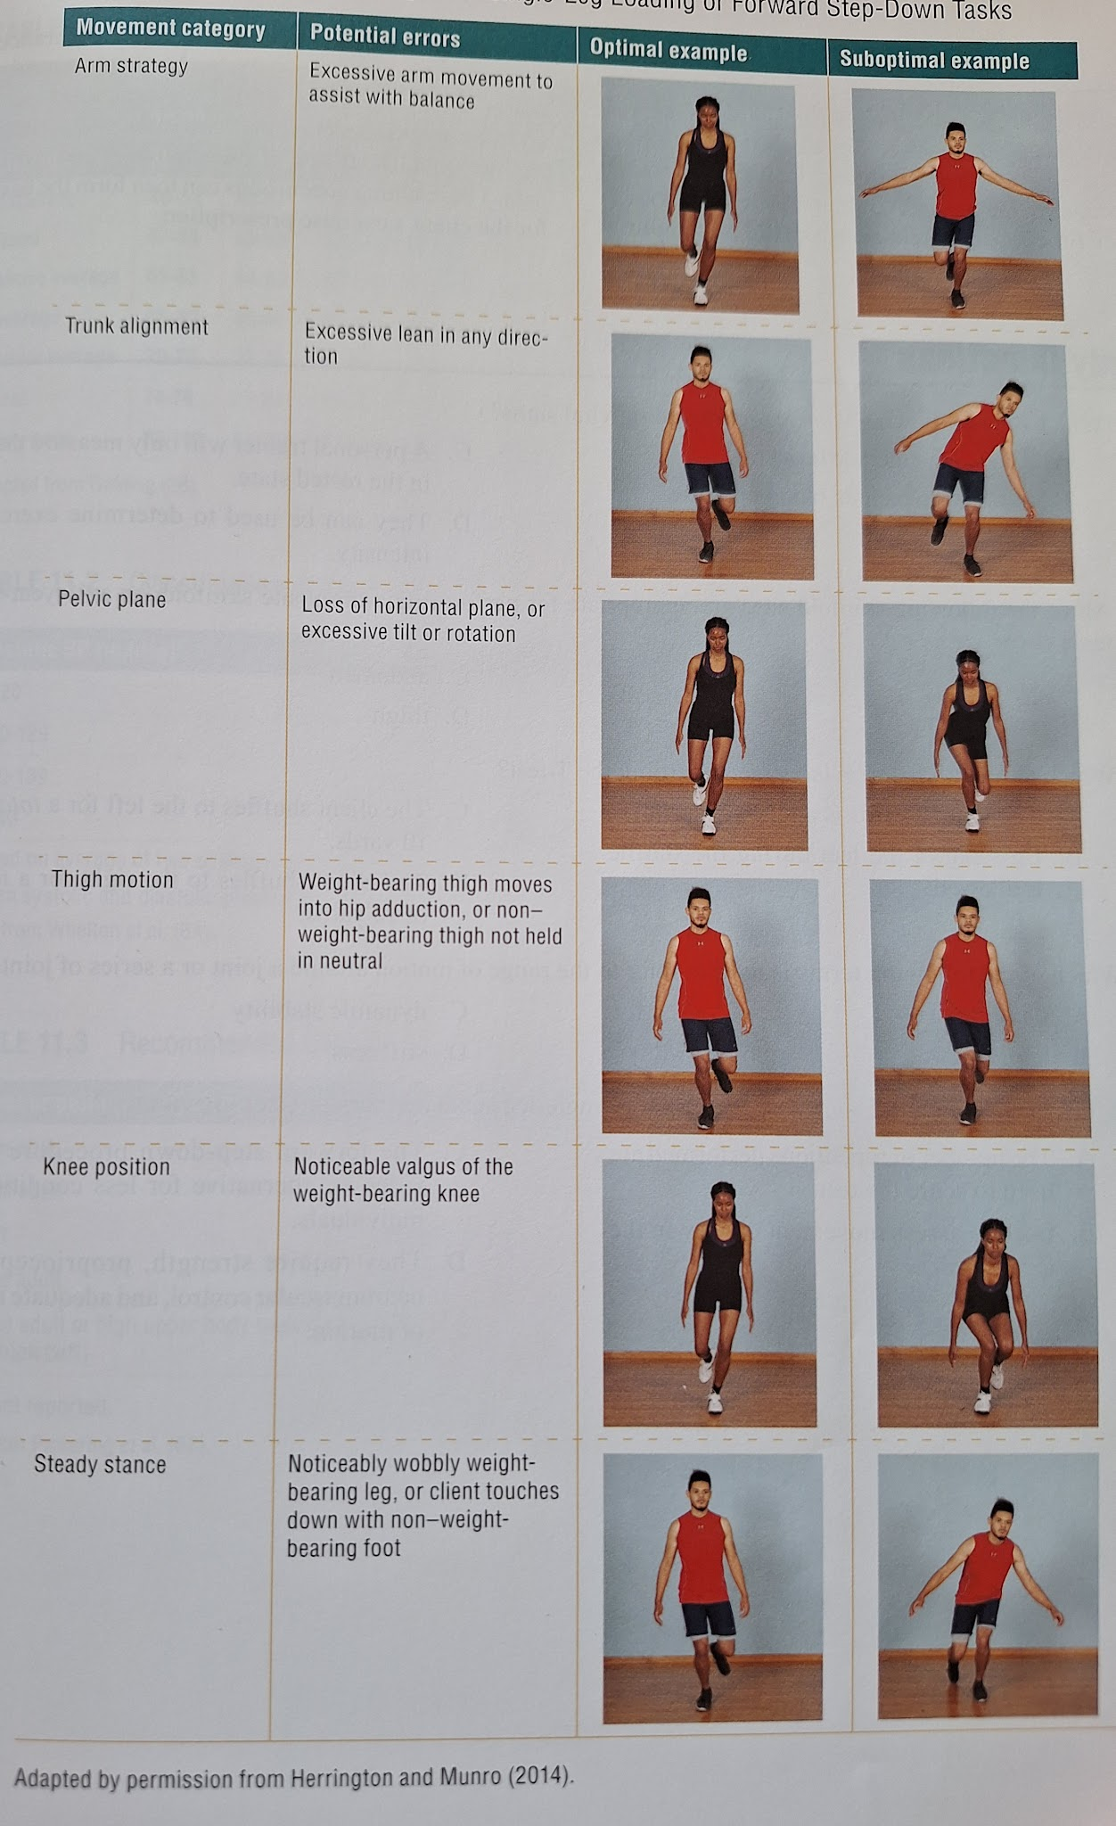

Chapter 12 - Flexibilitv and Warm-Up Concepts and Bodvweight and Stability Ball Exercise Technique
- There can be confusion about the notion that people must achieve extreme levels of flexibility to reduce the chance of injury and to improve movement capabilities. This does not accurately represent the role that flexibility plays in training.
- Flexibility is an important piece of the training puzzle; but like other aspects of training it must be based on the needs of the individual.
- According to a common definition, flexibility is the range of motion of a joint or a series of joints.
- For personal trainers, a more relevant definition might be the ability of a joint to move freely through the full normal range of motion (ROM).
- Every workout should be preceded by a warm-up session. However, the ideal time to perform flexibility training is dependent on the nature of the activity that is to take place during the workout.
- Achieving optimal flexibility helps improve movement efficiency by allowing joints to move freely through a full normal ROM, and it also reduces the risk of musculoskeletal injuries; prevents the development of muscular imbalances; and improves posture, strength, range of motion, and power.
- Improving flexibility is a fundamental element of any training program.
- Because of these important benefits, it is recommended that personal trainers supervise stretching just as they would any other part of the training session. Doing this communicates the importance of the warm-up and stretching period and may encourage clients to prioritize this portion of the training session.
- Flexibility training is important because of the role that flexibility plays in improving movement performance and reducing the opportunity for injury.
- Factors Affecting Flexibility
  - Joint Structure
    - Joint structures vary between individuals, and the personal trainer must consider this variation when evaluating flexibility.
    - Joint structure also varies between joints. Some joints offer a reduced ROM compared with others by virtue of their construction.
    - It is incorrect to think that a single flexibility test can provide an accurate measure of overall flexibility.
  - Muscle and Connective Tissue
    - Connective tissue (muscles, ligaments, and tendons is the area of emphasis during ROM exercise. This is because, under normal circumstances, connective tissues are the major structures limiting joint ROM.
    - Most of the differences between individuals in static ROM are due to the elastic properties of the muscle and tendons attached across the joints. "Stiff” muscles and tendons reduce ROM, while "compliant" muscles and tendons increase ROM. It is these elastic properties that are altered from stretching exercises.
    - When a muscle is held at a fixed length while under tension in a static stretch, the passive tension [i.e., the amount of external force required to lengthen the relaxed muscle] declines. (Effect lasting up to 20 mins).
  - Hyperlaxity
    - Hyperlaxity allows the joints of the body to achieve a ROM that exceeds what is considered normal.
    - If it has been determined that a client has joint hyperlaxity, the personal trainer should use caution when implementing a stretching program and should ensure that the client has been assessed by an appropriate health care professional.
  - Age
    - The biological age of an individual can have a significant impact on flexibility.
    - Although flexibility tends to diminish as one ages, this reduction may be partially attributable to a decrease in overall physical activity throughout the life span.
    - However, a well-designed flexibility training program is effective for increasing joint ROM among older adults.
  - Sex
    - Sex may also have a significant impact on flexibility levels. It is well known that the connective tissues of men and women differ physiologically, although the mechanisms contributing to these differences are not well understood.
    - After accounting for body weight, body mass, and limb size, sex-related differences in musculotendinous stiffness are incon- sequential.
  - Temperature
    - ROM is positively affected by an increase in either core temperature or external temperature.
    - The positive effect of increased core temperature on ROM points to the importance of warming up before participating in flexibility training.
  - Activity Level
    - As would be expected, people who are physically active tend to be more flexible than inactive individuals.
    - The decrease in flexibility in inactive individuals primarily occurs because connective tissues may become less pliable when exposed only to limited ROMs.
  - Resistance Training
    - A well-designed and properly executed resistance training program using exercises that are performed through a full range of motion can also increase flexibility.
    - All exercises should be performed through the full available ROM of the involved joints.
    - Although improper resistance training can impair flexibility, the reason is not usually that the person has become too muscular, or “muscle bound.” Instead the decrease occurs because of the improper development of a muscle or a group of muscles around a joint, resulting in a restriction of motion at that joint.
- Flexibility is influenced by a variety of factors. Some of these factors (e.g., joint structure, age, and sex) cannot be influenced by training. However, core temperature during flexibility training, overall activity level, participation in a well-designed resistance training program, and stretching on a regular basis can all affect flexibility and can be positively influenced by the personal trainer.
- Flexibility training targets two different tissue adaptations: elasticity and plasticity.
- Elasticity refers to the ability to return to original resting length after a passive stretch. Thus, elasticity provides a temporary change in length.
- In contrast, plasticity refers to the tendency to assume a new and greater length after a passive stretch, even after the load is removed
- Ligaments and tendons have both plastic and elastic properties. When connective tissue is stretched, some of the elongation occurs in the elastic tissue elements and some occurs in the plastic elements.
- The specific stretching techniques used by the personal trainer should be designed to produce a plastic elongation if a permanent increase in ROM is the goal.
- Active stretching occurs when the person who is stretching supplies the force of the stretch. In contrast, passive stretching occurs when a partner or stretching device provides the force for the stretch
- Types of Flexibility Training
  - Ballistic Stretching
    - Ballistic stretching involves continuous, rapid bouncing movements at the end ROM where the muscle is at maximal length.
    - It is generally no longer considered an acceptable method for increasing ROM because there is an increased risk of injury to the muscles and connective tissues associated with these types of movements, especially in joints where there has been a previous injury.
    - Disadvantages:
      - Increased danger of exceeding the extensibility limits of tissues involved.
      - Greater energy requirement.
      - Activation of the stretch reflex.
The stretch reflex occurs in response to the extent and rapidity of a muscle stretch.
It causes contraction of the previously stretched extrafusal muscle fibers (to protect themselves from overstretching).
  - Static Stretching
    - The most used method of increasing flexibility is static stretching.
    - A slow, constant speed is used. with the stretched position held for approximately 30 seconds.
    - Static stretching involves relaxation and simultaneous lengthening of the stretched muscle.
    - Static stretching does not activate the stretch reflex of the muscle.
    - There are no real disadvantages to static stretching in terms of injury potential if proper technique is used.
    - Individuals beginning a flexibility program may find it challenging to hold a stretched position for longer durations. Therefore. the personal trainer may initially decrease the duration of the stretch and progress to longer time intervals as tolerance improves.
    - To prevent activation of the stretch reflex, the client should move into the final static stretch position slowly and only to a point of minor discomfort. As the stretched position is held, the feeling of tension should diminish: if it does not, the stretched position should be slightly reduced.
    - Recommendations for Static Stretching
      - Stretching should be preceded by a warm-up of 5 to 15 minutes, until a light sweat appears.
      - Emphasize slow, smooth movements and coordinate deep breathing.
      - Properly performed stretches should cause no more than mild discomfort. lf clients feel pain, they are stretching too far.
      - Ensure that clients do not lock their joints.
      - To reduce the chance of activating the stretch-reflex, discourage bouncing.
      - Large muscle groups should be stretched first, and the same routine should be repeated every training day.
      - Stretches should be done at least three times per week and, to track performance improvements, should be done at the same time of day.
      - The ideal time to stretch is after aerobic activity or resistance training, when core temperature is maximally elevated.
  - Proprioceptive Neuromuscular Facilitation
    - It has since expanded to the conditioning of both athletes and the general population as a method of increasing ROM.
    - There are a variety of PNF techniques, but perhaps the most common method (i.e., the hold- relax method) involves taking the muscle or join into a static stretch position while keeping the muscle relaxed. After this static stretch position is held for about 10 seconds. the muscle is contracted for 6 seconds with a strong isometric contraction against an external fixed object (i.e., a force acting in the direction of the stretch).
After a very brief (1-2 second) rest. another passive stretch is performed for 30 seconds, potentially resulting in a greater stretch.
    - Because a partner is needed, PNF can be more time consuming than other methods, and the partner must be careful not to overstretch the muscle.
    - Practically, though, PNF methods are not generally needed.
  - Dynamic Stretching
    - Dynamic stretching avoids bouncing and includes movements specific to a sport or movement pattern.
    - An example of a dynamic stretch is a lunge walk in which the client exaggerates the length of the stride and flexes the back leg so that he or she ends up in a position in which the front knee is over the toe (but not in front of it) and the back knee is just off the flor.
    - Dynamic stretching emphasizes functionally based movements.
    - Personal trainers who wish to implement dynamic flexibility training in a client's program should begin dynamic stretches with low volume and low intensity because dynamic flexibility exercises require balance and coordination.
    - Many of the guidelines established for static flexibility training programs are also applicable to dynamic flexibility training.
    - There are two primary advantages of combining movements. First, the variety is greater, so the program is less likely to become monotonous. Second, combining stretches is more time efficient because the client is stretching a larger number of muscle groups rather than duplicating the same stretch repeatedly.
    - The number and types of dynamic stretches that can be used is limited only by the creativity of those designing the programs.
    - Dynamic and PNF stretching may be the most appropriate types of flexibilitv training for improving movement capability before a workout. If additional flexibilitv work is needed, performance of static flexibilitv exercises after the workout is effective.
    - Recommendations for Dynamic Stretching
      - Moderation and common sense are important.
      - Flexibility is just one component of fitness and should not be overemphasized
      - The stretch should never be forced. If the stretch hurts, it should be discontinued.
      - Flexibility training should be combined with resistance training.
      - Flexibilitv should be joint specific based on the needs of the client and the requirements of the activity.
      - Ballistic stretching should be avoided.
      - Stretching movements that position the body in the most functional stance possible, relative to the involved joints and musculature to be stretched and the activity requirements of the client, should be emphasized.
      - It is important to make use of gravity, body weight and ground reaction forces when stretching.
      - The dynamic flexibility training program should be specific to the demands of the sport or activities the client takes part in. The individual flexibility requirements of the client are also an important consideration.
      - Improvements in flexibility can occur from day to day.
      - Additionally, once increases in ROM have occurred, it is easy to maintain that ROM. Maintaining flexibility requires less work than improving it does.
      - Clients should stretch the large muscle groups first and repeat the same routine every training day.
      - As areas that are less flexible become apparent, a greater emphasis can be placed on performing additional stretches for those muscle groups and joints.
      - Train for dynamic flexibility at least three times per week or along with each exercise session. To track performance improvements, clients should be consistent with the time of day they perform dynamic flexibility training, remem- bering they are least flexible in the morning
      - Stretching should take place after the core temperature has been elevated.
- A combination of dynamic and static flexibility training is recommended when the goal of training is increased ROM.
- Warm-up is an activity that raises the total body temperature, as well as temperature of the muscles to prepare the body for vigorous exercise.
- Warming up is a part of the foundation of a successful practice session. Getting fully warmed up, mentally and physically, is a key aspect of attaining the training intensity required to achieve optimal results.
- Unfortunately many clients attempt to take shortcuts in the warm-up procedure, which may translate into poor performance and increased injury risks.
- Flexibility exercises should not be used as the sole method of warming up. Instead, they should be performed after core temperature has been elevated to a point that the client is beginning to perspire.
- Types of Warm-Up
  - Passive Warm-Up
    - Passive warm-up involves such methods as hot showers, heating pads, or massage.
    - One obvious advantage of a passive warm-up is that it does not fatigue a client before an exercise session.
    - Unfortunately, passive warm-up procedures (.g., a moist heat pack) may not be practical in many settings.
  - General Warm-Up
    - A general warm-up consists of basic activities requiring movement of the major muscle group.
  - Specific Warm-Up
    - Unlike general warm-up, specific warm-up includes movements that are an actual part of the activity, such as slow jogging before going out on a run or lifting lighter loads in the bench press exercise before progressing to the workout weight. A specific warm-up appears to be the most desirable method because it increases the temperature of the same muscles that will be used in subsequent, more strenuous activity and may also serve as a mental rehearsal of the event, allowing complex skills to be performed more effectively
  - RAMP Warm-up
    - The RAMP warm-up is a systematic method of pre- paring the body for more vigorous activity. It consists of three main phases: raise. activate and mobilize and potentiation.
- Warm-Up Guidelines
  - The amount, intensity, and duration of the warm-up should ideally be adjusted to every individual depend- ing on his or her level of fitness.
  - In general, the warm-up activity should last approximately 5 to 15 minutes, long enough for the individual to break into a light sweat.
  - As conditioning improves, the intensity and duration of the warm-up need to increase.
  - The warm-up should not create significant fatigue.
- Bodyweight training
  - Bodyweight training is simply a mode of resistance training in which the resistance is provided by the body rather than by an external weight such as a barbell or the weight stack of a selectorized machine In cases in which no equipment is available or if the client prefers this type of training, bodyweight training is a viable option.
  - The personal trainer needs to be aware that clients will not develop maximal strength or power with bodyweight training because it cannot provide the intensity necessary to develop these physiological adaptations.
  - Emphasis must be on performing each exercise in a slow, controlled manner with perfect technique.
- Suspension Training
  - Suspension training describes a specific type of bodyweight training that uses adjustable straps suspended from an overhead anchor point.
  - First, it allows the client to overload specific muscle groups and exercises, and second, it allows for a range of intensities that may be difficult to accomplish via traditional calisthenic bodyweight training.
  - The degree of resistance varies depending on the individual's center of mass in relation to the anchor point.
  - The intensity of many upper body pulling exer- cises, such as a suspension row, increases when using a single-arm variation.
  - Like other forms of body weight exercise, the total volume load for suspension training is difficult to quantify.
  - For this reason, suspension training may not be the most appropriate form of training for all training goals and all situations because stronger individuals may have a difficult time overloading the targeted musculature using this modality. However, the addition of other devices, such as weighted vests. can safely increase the training load of many suspen- training exercises
  - The degree of resistance when performing a suspension training exercise varies depending on the individual's center of mass in relation to the anchor point.
  - Recommendations for Suspension Training:
    - Securely anchor the suspension training system to a stable object.
    - Adjust the length of the straps based on the exercise and desired intensity level.
    - After adjusting the strap length, the personal trainer should make sure the straps are even in length.
    - Make certain the handles and foot cradles are secured and do not slip when load (i.e., the client's body mass) is applied.
    - Make certain the client has a firm, closed grip of the suspension trainer handles when using the straps for support.
    - Ensure the feet are securely in the foot cradles before the client begins exercises aimed at developing the legs or trunk.
    - When performing suspension training exercises that involve holding onto the handles: To increase the difficulty, clients lower the body closer to the floor by stepping toward the anchor point To decrease the difficulty, clients step away from the anchor point.
    - To emphasize balance and stability, the foot position can be made narrower (i.e., feet together to hip width). To increase stability and force production, the base should be wider (i.e. hip to shoulder width)
    - Allow time for the client to become familiar with each suspension trainer exercise.
    - Emphasize correct technique, which will limit client fatigue.
- Manual Resistance Training
  - Manual resistance training involves the application of an external resistance, applied by a partner or personal trainer via manual muscle force, through a full or partial range of motion for an exercise.
  - It allows a personal trainer to use an accommodating, rather than a constant, resistance throughout the full range of an exercise.
  - Manual resistance training can be a viable method of developing muscular fitness if the acute training variables of resistance training (i.e., intensitv. volume. and rest) are appropriately applied.
  - Recommendations for Manual Resistance Training:
    - For manual resistance exercises that require the personal trainer to lay hands on the client, the client should be informed beforehand about the procedures and provide consent.
    - Check for damage to any equipment being used to apply manual resistance to make certain it does not create a safety risk.
    - When applying manual resistance, adjust the training load based on the number of goal repetitions to achieve the desired muscular adap- fation.
    - The amount of resistance applied should be consistent throughout the entire range of motion for the exercise selected.
    - In general, applying resistance to the distal end of a seament is more challenging than when this resistance is applied more proximal
    - Clients should maintain correct form throughout the entire exercise movement.
- Stability Ball Training
  - The primary motivation for the use of stability balls in these applications is the belief that an unstable surface will provide a greater challenge to the trunk muscles. increase dynamic balance, and possibly help stabilize the spine to prevent injuries.
  - Research Findings
    - Stability balls and core activation
    - Stability balls and core training
    - Other potential benefits
    - Potential disadvantages
    - Stability balls in sport performance training programs
    - Importance of training specificity
    - Effect of unstable base on force output
  - Personal trainers might choose to incorporate instability into training programs via methods other than stability ball training. Two such methods are described here:
    - Emphasis on structural multijoint exercises (e.g. squats and deadlifts)
    - Instability with free-weight training. Free-weight training can provide a moderate degree of instability.
Another way to augment instability in free-weight training is to emphasize unilateral over bilateral dumbbell training.
  - It is important that people start off with basic, less complex exercises and increase the complexity over time.
  - People with long hair should tie it back so it does not get caught during movements.
  - If an exercise causes pain, the personal trainer should modify the movement or the movement should be discontinued.
  - Making sure the ball is correctly sized. The individual should sit on the ball: the size is correct if the thighs are slightly above parallel to the floor.
  - One investigation showed a significant increase in abdominal muscle activity when a crunch was performed on a stability ball in comparison to the same movement performed on the floor, but only when the ball was correctly placed.
  - Guidelines for Stability Ball Training
    - The stability ball should be fully inflated so that it is firm.
    - The stability ball should be the correct size for the client. To determine the correct size. have the client sit on the ball with feet on the floor. In this position the thighs should be parallel or slightly above parallel to the floor.
    - As with other modes of training, a warm-up session of 5 to 15 minutes should precede the actual workout.
    - Allow time for the client to become familiar with the ball (especially if they train mostly with machines).
    - Emphasize correct technique. Attention to detail is critical when clients perform exercises on a stability ball.
    - The number of sets and repetitions performed will depend on the fitness level of the client.
- [Note] Here there are a lot of very nice exercises, and a lot of important information about them. I decided not to write notes/take pics of them to not be too verbose (I'd be copying basically everything). Please refer to the book in case you wanna know more about these.
  - Common errors are also very interesting
- Static Flexibility Exercises
  - Look Right and Left
  - Neck Flexion and Extension
  - Hands Behind Back
  - Behind-Neck Stretch
  - Assisted Lat Stretch
  - Side Quadriceps Stretch
  - Pretzel
  - Forward Lunge
  - Lying Knee to Chest
  - Semistraddle (Modified Hurdler's Stretch)
  - Butterfly
  - Wall Stretch
  - Step Stretch
- Dynamic Flexibility Exercises
  - Arm Circle
  - Arm Swing
  - Lunge Walk
  - Variation: Reverse Lunge Walk
  - Hockey Lunge Walk
  - Variation: Walking Side Lunge
  - Walking Knee Tuck
  - Walking Knee Over Hurdle
  - Inverted Hamstring Stretch
  - Dynamic Pigeon
  - High Kick
- Bodyweight Exercises
  - Abdominal Crunch
  - Variation: Twisting Crunch
  - Back Extension
  - Variation: Twisting Back Extensior
  - Push-Up
  - Variation: Modified Push-Up
  - Heel Raise
  - Step-Up
  - Zombie Squat
  - Shoulder T (Bent-Over Reverse Fly)
  - Single-Leg Hip Bridge
- Suspension Training Exercises
  - Suspension Inverted Row
  - Suspension Y-Pull
  - Suspension Ab Fallout
- Manual Resistance Exercises
  - Manual Resistance Lateral Raise
  - Manual Resistance Single-Arm Towel Row
  - Manual Resistance Push-Up
- Stability Ball Exercises
  - Extended Abdominal Crunch
  - Supine Leg Curl
  - Supine Hip Lift
  - Back Hyperextension
  - Reverse Back Hyperextension
  - Elbow Bridge
  - Variation: Straight Arm Roll-Out
  - Stability Ball Push-Up (Feet on Ball)
  - Stability Ball Push-up (Hands on Ball)
  - Pike Roll Out and In
  - Variation: Knee to Chest (Jackknife)
  - Stability Ball Side Crunch

Chapter 13 - Resistance Exercise Technique

